Michaela Fishback
Aakash Upraity
ENVS203
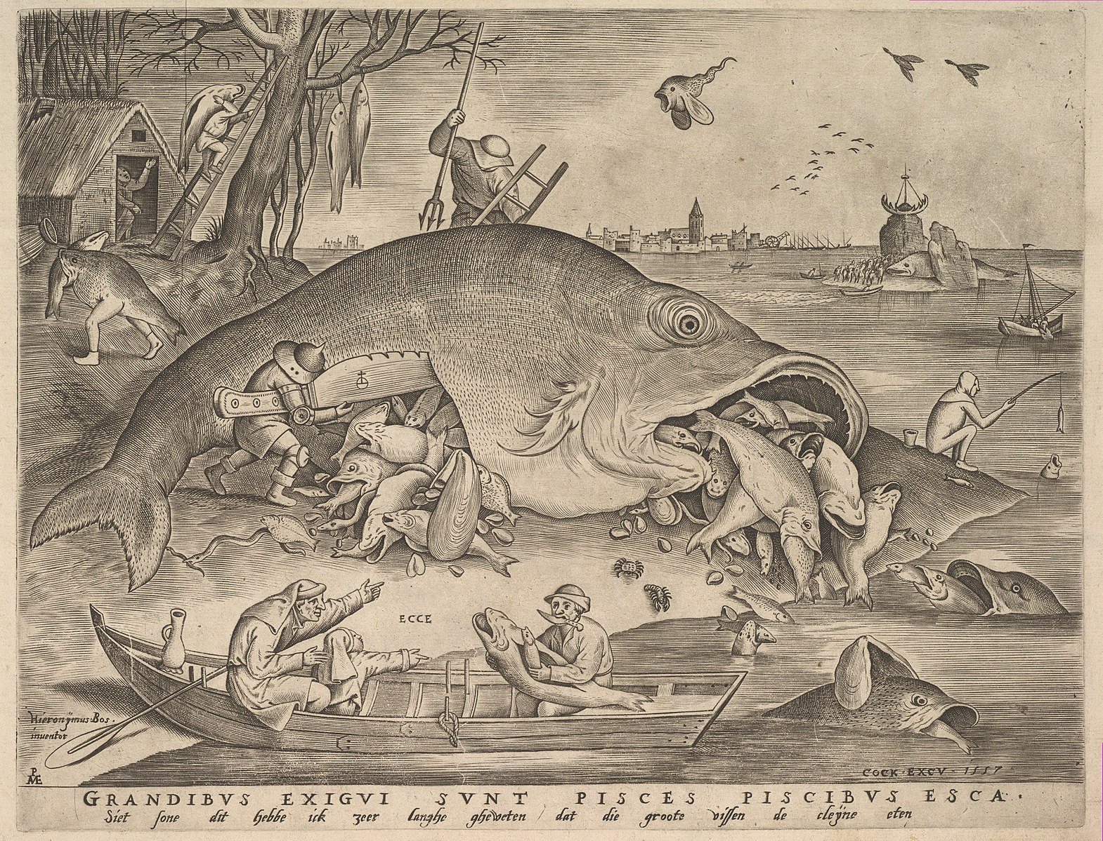
June 13, 2017

“I Have Long Known That The Big Fish Eat The Small”
Environmental Analysis of Longstanding Consumer Society
The perils of consumer society were hardly a prioritized concern in the mind of the average person in 1557. Yet the groundwork for conditions faced today were already set in place. Big Fish Eat Little Fish is an engraving done in 1557 by Pieter Bruegel, a Flemish renaissance artist. The work depicts a fisherman and his son looking at a large fish with several smaller fish spilling out of its mouth, many of them with even smaller fish spilling out of their mouths. There is an inscription at the bottom of the piece which translates to, ‘Look son, I have long known that the big fish eat the small,’ a vernacular expression of the latin proverb for which the piece is named. At this time, making statements on social conditions through metaphors in art, somewhat like satirical works today, was just becoming popular. Bruegel in particular did many works on the dynamics of social classes. In Big Fish Eat Little Fish, Bruegel uses the latin proverb to illustrate the propensity of hierarchical western society to consume in excess, highlighting negative effects of industrial capitalism on the environment.
The evidence of consumption occurs in the drawing with the giant fish, the fisherman, and the walking fish. Almost every object in the drawing is engaged in activity related to consumption, though the most obvious example is the largest fish laying dead on the shore. The fish simultaneously reflects both the consumer and that which is consumed, shown by the fact that it was caught but has itself already caught the thirty-some fish that spill from its gaping mouth and open side. The number of fish within the already huge fish magnifies the scale of the consumption that the fishermen engage in; they’re not just pulling in a huge fish, they’re obtaining that huge fish plus all the others. It also appears that the fish was already close to bursting open with the volume of fish piled around it, adding to the magnitude of its consumption. Reinforcing this theme, above the main fish is a little fish with wings flying across the composition. This gaping-mouthed surreal beast gasps at the air, seeking to gather anything that crosses its path. This too represents consumption due to the fact that this figure’s innate instinct is to consume as much as it can, all the time. On the left, a figure like a fish with human legs walks away from the water, carrying another fish in its mouth. This implies the intensified act of eating to the extent that a man completely engulfed in eating fish has actually become a fish.
These variations on the dominant theme of consumption occur across species, environments, and different levels of the frame, acting as metaphors for the various forms of power relations in consumer society. Though the proverb only literally addresses eating fish, it refers to the societal practice of overcoming those that are weaker for one’s own advancement. This is also called ‘climbing the ladder,’ and in the drawing, there are two different ladders being climbed; one by a fisherman, so he can gain a better position to attack the giant fish, and the other by a man carrying a cut-open fish, which is held such that the man’s face is hidden underneath it. Some climb ‘the ladder’ in order to consume larger things on a larger scale, others climb the ladder just by being so part of consumerism that it masks or becomes their identity, and carry out that act of striving towards more power as they consume more. Consumer society in the United States didn’t emerge until the 20th century with the advent of flashy advertising and mass marketing campaigns. In current society, ‘buying things [has] evolved into an ever more important way of moving through the world.’ (Looking for Nature at the Mall, Price, 1999, p196) ‘We use the things we buy to create ourselves. The clothes, the sound systems, the books, computers, cars and bumperstickers: we use these not only as key tools to work and to have fun, but also to act, think and communicate.’ When people buy things because they are higher tech, bigger, better, they do so in part because having more efficient things tends to make life easier, often leading to greater power, like the ladder at the center. But members of consumer society also buy the higher tech things because they communicate status and power about the buyer’s identity, like the ladder to the left. In such a society, it is possible to define who has power and who doesn’t by who consumes the most at the highest level.
Through the lens of consumption, one can contextualize environmental Marxist theory on capitalism in Bruegel’s drawing. Capitalism at its core requires that workers make money, then spend money, furthering the demand for what they buy and furthering the demand for more workers. Though Bruegel made Big Fish Eat Little Fish long before the rise of capitalism, extensive consumer practices were already in place, as visualized in his drawing, and the notion of industry was not far away. Bruegel included the image of a city on the horizon, and with current understanding on the basic mechanisms of capitalism, it’s not difficult to make the connection between the distant setting of developing society and the up-close scene of extreme consumption. There must be constant growth and a strict hierarchy of workers and buyers in order for a capitalist economic system to continue. (Bacon, 5th lecture) Karl Marx theorizes that, ‘all progress in capitalist agriculture is a progress in the art, not only of robbing the worker, but of robbing the soil… simultaneously undermining the original sources of all wealth--the soil and the worker.’ (Marx, 1867) Though resource management was yet to be anyone’s concern when Bruegel made this piece, with the current plight of natural resources occurring on an ever-increasing scale, all in the interest of economic growth, the image sheds light on early perspectives of the land in relation to industry.
Western perception of the relationship between humans and the land often guides ideas on protection of the land in an increasingly exploitative world. Aldo Leopold offers the field of ethics as a mode to consider human relationship to the land over the traditional economic mode for ‘there is as yet no ethic dealing with man’s relation to land and to the animals and plants which grow upon it. Land is still property. The land-relation is still strictly economic, entailing privileges but not obligations.’ (Leopold, 2) He describes an ethic in ecological terms as ‘a limitation on freedom of action in the struggle for existence.’ (1) Certainly, in the 16th century, fishing was done for survival. However, by the time of Big Fish Eat Little Fish, it had reached the scale as shown in Bruegel’s work, and perhaps was beginning to need such an ecological ethic as Leopold describes. In order for such dramatically excessive consumption to occur in the scene of Big Fish Eat Little Fish, there was clearly no obligation to the maintenance or respect of the land. Instead, the fish are viewed economically, as objects to be used for their value in relation to furthering the economy, rather than kept in existence for their deeper intrinsic value. This is often still the case, as conservation efforts tend to require some economic foothold on which to focus their goals in order to gain any traction in policy reform. However, as Leopold points out, this is a losing game, as ‘most members of the land community have no economic value.’ (6) Instead, there is value in members’ role in sustaining the community as a collective. However, collective benefit is not congruent with success in the hierarchical capitalist consumer culture.
The commodification of land in Big Fish Eat Little Fish as seen in the man carrying a fish up the ladder, the man cutting into the giant fish, and the man stabbing into the giant fish bears strong resemblance to current treatment of land by Western society. Ecofeminist theory illustrates many of these similarities within the frame of relationships across hierarchical binaries. Most binaries follow the structure that the Subject carries autonomy and dominance, where the Object is submissive and exists only in relation to the Subject. In most cases, things are equated with unrelated things simply because they exist on the same side of a binary. For example, man is thought of as superior to women, and civilization as superior to wilderness, thus man is associated with ideas of industry and women are associated with ideas of nature. (Bacon, 4th Lecture) Ecofeminists are particularly interested in the implications of this for observing the historical plight of the land as relative to the historical plight of women. There aren’t any women in Bruegel’s piece, but there are several men. The man carrying a giant knife stabs into the giant fish, tearing a large slit in its side, out of which a bounty of small fish emerge. This evokes the idea of female pregnancy and birth upon male penetration. The man climbing the ladder on the left of the piece carries a fish, with a deep gash again evocative of a vagina, slung over his shoulder as his defeated possession. The fisherman on the other ladder stands poised to sink a spear into the back of the fish in a redundant effort to defeat it. All of these show a carnal desire to subdue and take from the natural elements pictured, similar to lasting frontier-based values that encourage patriarchal control over the land. William Cronon cites Frederick Jackson Turner saying, in 1893, that as European immigrants moved ‘to the wild unsettled lands of the frontier, shed the trappings of civilization, rediscovered their primitive racial energies, and thereby reinfused themselves with a vigor.’ (Turner in Cronon’s The Trouble with Wilderness, 77) Cronon continues, ‘The mythic frontier individualist was almost always masculine in gender: here, in the wilderness, a man could be a real man, the rugged individual he was meant to be before civilization sapped his energy and threatened his masculinity.’ (78) From Cronon’s theory one is able to see Big Fish Eat Little Fish as an example of the very masculine conquering of the bounty of nature.
Adhering to capitalist methods of binaries and exploitation ultimately perpetuates the disturbing scene of Bruegel’s drawing. The mass consumption that is portrayed, of everything eating each other and being eaten at the same time, is almost grotesque in nature. While the drawing was made long before the historical origins of modern systems and values, such as capitalism, industrial practices, and the frontier, it smoothly fits within all of them. Though it might seem odd that we could still be faced with similarly uncomfortable problems of environmental destruction as were faced centuries ago, Bruegel demonstrated the ongoing persistence of hierarchical consumption right on the drawing. The man says to his son, as though bestowing old knowledge, ‘long have I known that the big fish eat the small,’ to continue the idea for the following generation. This one line explains that it has long been this way, and, at the time Bruegel made the piece, it would continue in this way for a long time to come.

Works Cited
The Land Ethic, Aldo Leopold, 1949
Looking for Nature at the Mall, Jennifer Price, 1999
The Trouble with Wilderness; Getting Back to the Wrong Nature, William Cronon, 1995
J.M. Bacon Lecture on Karl Marx environmental theory
J.M. Bacon Lecture on Ecofeminism

