A Study on the Effect of Decreased Precipitation and Soil Absorption in Southeastern Semi-Arid Arizona on Species Diversity of Riparian Zones
Michaela Fishback
IB# 000517-0017
Supervisor: Maureen Kenny
Biology
Word Count: 3,765

Table of Contents:
Abstract…………………………………………………………………………………..3
Introduction………………………………………………………………………………4
Methodology……………………………………………………………………………10
Results………………………………………………………………………………….17
Analysis…………………………………………………………………………………23
Conclusion……………………………………………………………………………...26
Works Cited…………………………………………………………………………….28
Appendices A…………………………………………………………………………………29
B…………………………………………………………………………………30
C…………………………………………………………………………………43
D…………………………………………………………………………………54

Abstract:
Drought is a prolonged period of abnormal dryness. It’s also one of the many adverse effects of increased CO₂ concentration in the atmosphere and subsequent climate change. Biodiversity is an important component of any ecosystem, often accounting for its overall sustainability. This paper aimed to find the extent to which decreased precipitation and soil absorption in semi-arid southeastern Arizona affect biodiversity of riparian zones. In order to investigate the relationship these two things, I averaged annual precipitation totals from 88 rain gages in an experimental watershed near the Mexican border from 1954 through now and recorded this as a visual graph. This process was further focused by displaying total precipitation from the same gages in the months of May and July over the same period of time. I observed annual amount of runoff in this area in a similar manner for information about the soil absorption of water. I related this to biodiversity of semi-arid riparian regions, at the same location as the center providing precipitation and runoff data. The scope was restricted to fit within the limitations by omitting the effect of evaporation in the dryness of a region and only focusing on two variables. It was limited by the fact that I was unable to take primary data on the variables considered and had to instead find reliable published sources relevant to my topic. While the trends in processed data failed to directly correlate with increased frequency of drought, they revealed an increase in variability of yearly weather patterns. Species diversity and abundance was found to be greater closer to the river in riparian habitats than farther away in shrub-desert habitats. Biodiversity was therefore found to be at risk in southeastern Arizona due to climate change that contributes to more intense drought.

Word Count: 294
Introduction:
To what extent do trends in precipitation and soil absorption in southeastern semi-arid Arizona affect terrestrial plant and animal species diversity richness of riparian zones?
Biodiversity refers to the diversity in biological content of a region. This is determined by the variability within a species, between species, and within an ecosystem. (Marvier) Biodiversity thus describes the variety of life through a focus on defining an expanse of living organisms. Biodiversity is quantified through species diversity, the number of different species, and of individuals from each species, living within a community.
Biodiversity carries many implications about the sustainability and state of the environment overall. Low species diversity primarily suggests there are few successful species, and that the environment is therefore stressful to inhabit with few available ecological niches. Further, this suggests that changes in the environment would bring about dramatic effects for the ecological community occupying it. High species diversity suggests a greater number of successful species and a large array of interactions between species. This would reflect a more stable ecosystem, the community of interacting species when looking from a wider window that includes the physical environment. There are more ecological niches available, the environment is less likely to be hostile, and disturbance in components of the ecosystem are less likely to affect the community structure.

Species diversity cannot, however, be used to understand the biological health of any given habitat. (Chapin, et al) Some habitats are naturally stressful and there are only more rare organisms adapted to it. Still, drastic changes in species diversity can provide ample reason to investigate possible threats to the health of a habitat. In carrying out this study, I will be looking at the levels of biodiversity in response to stressful climactic conditions that occur in southeastern Arizona.
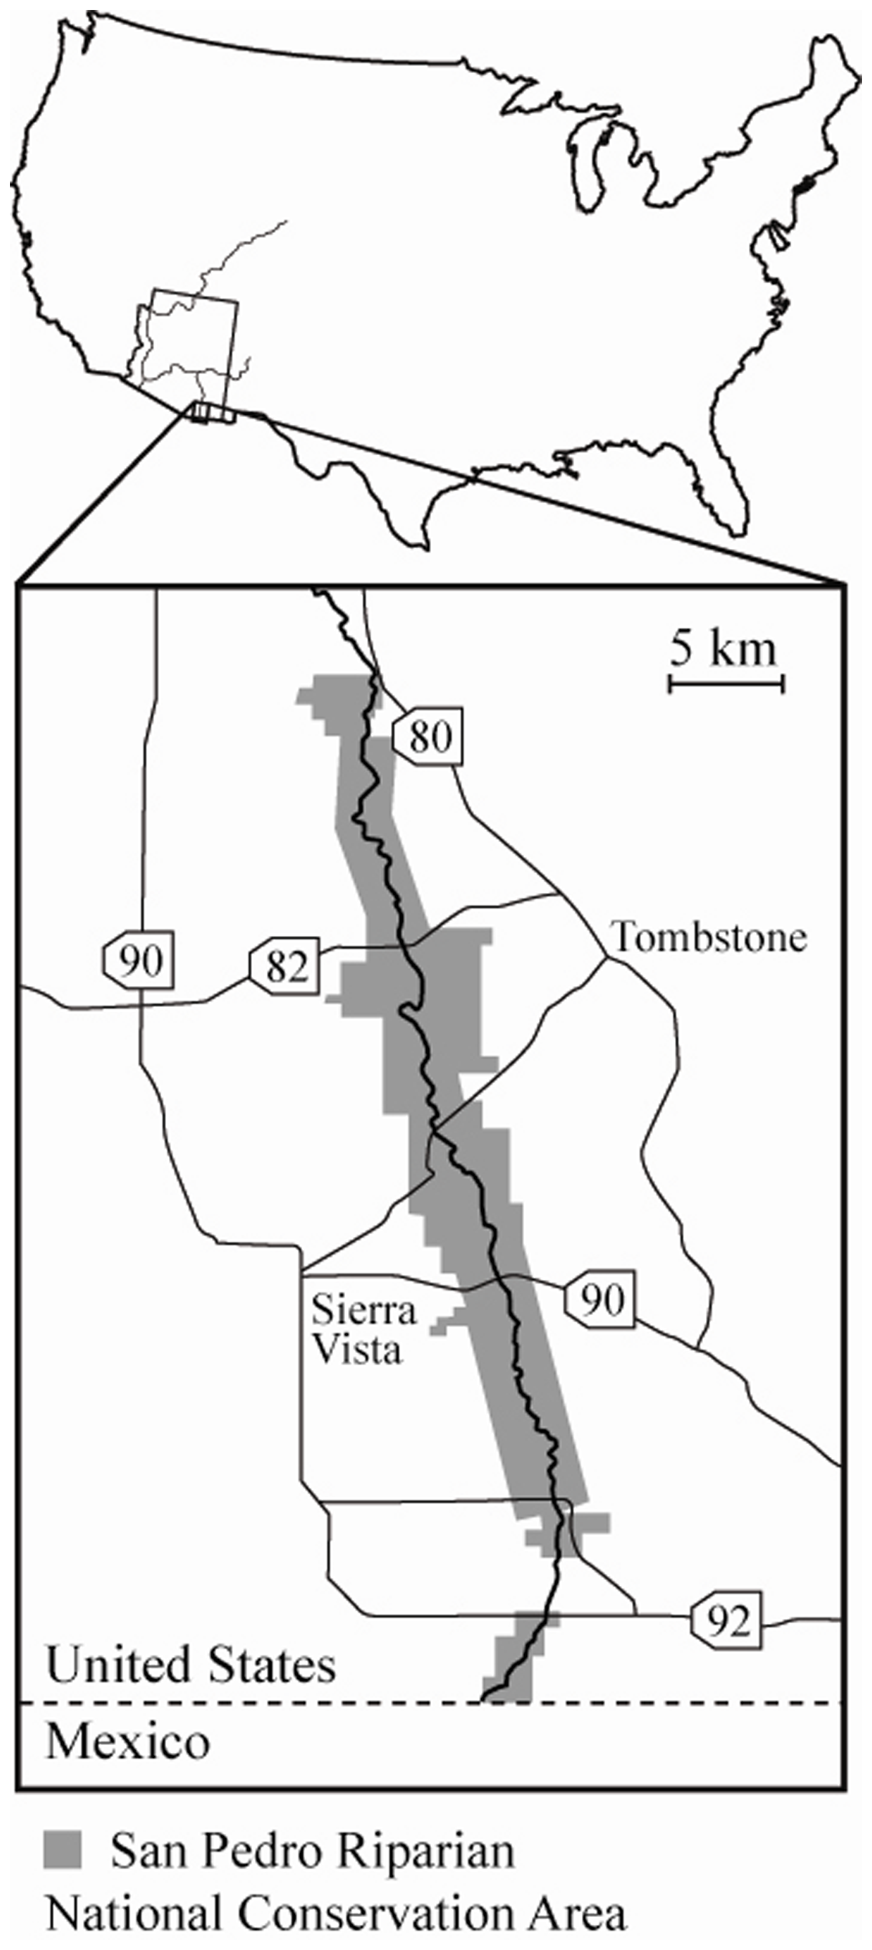
Southeastern Arizona is a semi-arid region of the state. Semi-arid climates are those which are classified as such by meteorological data relating precipitation and evaporation. They are generally desert areas with extremely hot summers and mildly warm winters with little to no snowfall throughout the year. (Peel) This study will primarily rely on data from a research center part of the United States Department of Agriculture. The Walnut Gulch Experimental Watershed is nearest the town of Tombstone, Arizona, an area which used to be mostly grassland within the past 100 years, roughly 2/3 of which is now dominated by shrubs. The watershed of the San Pedro River forms an arid riparian zone climate in the desert landscape. Watersheds are where geological features form a perimeter ridge, a drainage divide, that causes surface water to trickle down and converge at the lowest, center-most areas. (DeBarry) Riparian zones, the interfaces between a river and the land it goes through, are notable for their ecological role in landscapes due to the increased wildlife habitat and therefore biodiversity they provide. Riparian areas also help with landscape irrigation. The Walnut Gulch Experimental Watershed (WGEW) is operated by the Southwest Resource Center (SWRC) and studies the local semi-arid rangeland hydrologic, ecosystem, and climate processes, making it highly beneficial in better understanding meteorological influences on the environment.
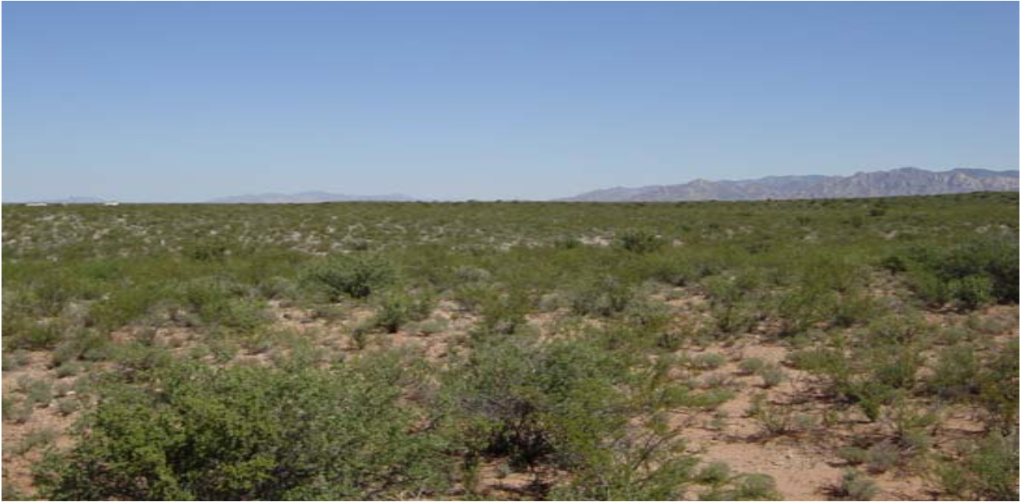
Figure 1: Shrub-dominated lower part of watershed (WGEW Brochure)
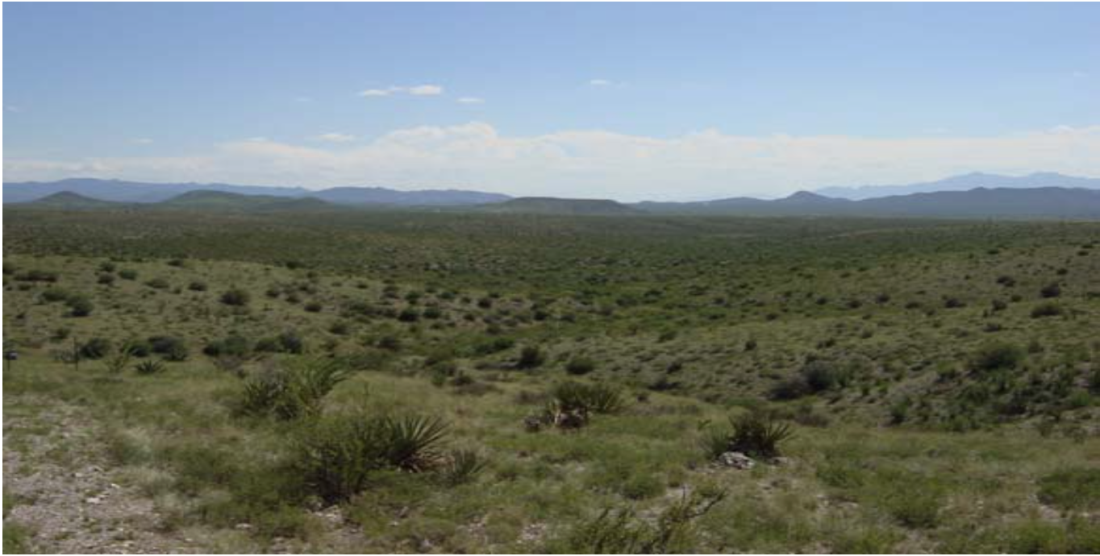
Figure 2: Grassland upper part of watershed (WGEW Brochure)

Droughts have been occurring more frequently with recent global climate change. Though global warming due to human causes remains yet to be explicitly proven, there are many strong correlations between human actions and the increased CO₂ concentration of the atmosphere. As CO₂ concentration rises, so does the amount of solar radiation that is reflected back to the earth. This results in a variety of climactic change, including more erratic weather patterns. Droughts occur when an area is dryer than average, found by comparing precipitation rates with evaporation rates in order to determine overall rate of soil-moisture depletion. (Ponce, et al) The primary area I will be assessing precipitation and soil hydrology data from, the watershed near Tombstone, Arizona, has a mean annual temperature of 17.7°C and a mean annual precipitation of 350mm. On average there are 53 days of precipitation per year, about 2/3 of which occur during July, August, and September. It has a drainage area of about 149km² and is a tributary of the San Pedro river.
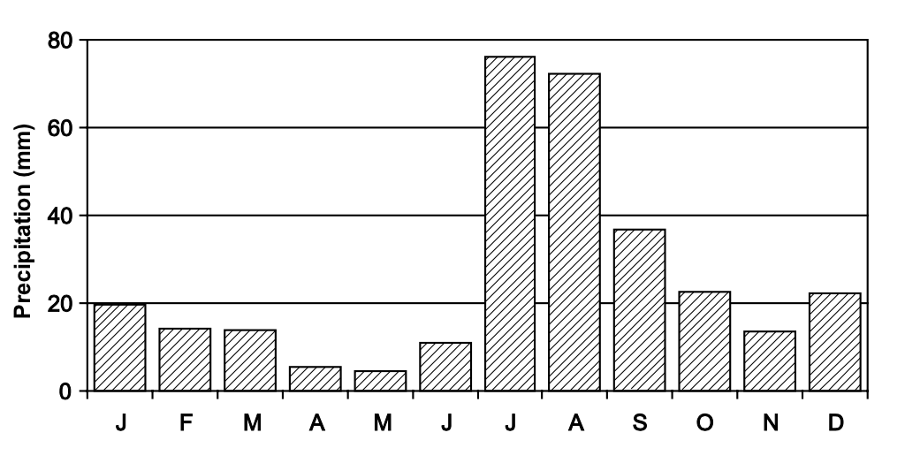
Figure 3: WGEW average monthly precipitation of six rain gauges from 1956-2005 (Goodrich, et al)
Drought can have many impacts that affect more than just the physical area that is experiencing drought. (Ponce, et al) Dryness in agricultural-intensive areas has huge impacts on the economy of not only the community that operates the crops but also of the consumers of these products. Drought increases the risk of insect infestations, plant disease, damage to habitats, air and water quality, and fires. (Ponce et al) Observed on a global scale, increased frequency of drought becomes a serious problem.
I’m interested in the effect of the relationship between lower rates in precipitation and soil absorption on species diversity of southeastern Arizona. Because biodiversity can reflect the overall health of the environment, in an area where conditions are subject to extreme conditions and prolonged periods of dryness, the affects of drought on biodiversity may be especially useful to study. This research carries implications about the threat to species diversity in other dry areas or increasingly dry areas in the world.
Drought and climate change cannot be examined only by trends in precipitation. Another important factor is the capacity of semi-arid to arid terrain to absorb large amounts of rainfall in a short period of time. (McNab, et al) If the terrain is unable to do so, flash floods occur and water spreads across the surface of the ground rather than going into the earth where flora can utilize it, forming runoff. Greater amounts of runoff imply that the ground has been parched for a longer period of time as it is unable to pull in the water. Additionally, greater runoff can indicate declining abundance in vegetation, as it is uptake of ground water into vascular plant roots that catalyzes efficient absorption of water. Therefore, I will be looking at the amount of runoff in the Walnut Gulch Experimental Water Shed over time for a better understanding of the affects of climate change on the area’s overall dryness.

Methodology:
I encountered a problem with the effectiveness of my study when, in beginning to look for primary sources, I found that raw data is rarely included in published material. Scientific articles will instead only discuss conclusions they’ve formed, accompanied by a few graphs that represent overarching trends in large amounts of data. However, the comprehensive data itself is most often kept private by whichever research group took it, and left out of the final work. My original intent in this study was to find published, unprocessed data on precipitation and species richness in southeast Arizona, then process it on my own and describe any trends that would be revealed. Government-funded national resource agencies were helpful for information about the state of the climate. For information about Arizona’s biodiversity, I searched for and collected the most detailed research publications from science journals that I could find. I also found useful publications on the climate from the same government websites that had meteorological databases.
The WGEW has been in operation since 1953, and has made all data they’ve taken for experimental purposes from the past 62 years available through an online public domain. (Goodrich, et al) They observe and publish a small variety of different types of information about the area, including precipitation, runoff, sediment data, meteorologic and soil moisture, soil erodibility, vegetation, and geology. However, their primary focus is on taking consistent data on the rainfall and runoff throughout the rangeland they operate from.
In order to establish information on the spatial and temporal variation of precipitation across the basin, the research center runs a network of 88 rain gauges. (Goodrich, et al) This constitutes one of the densest networks in the world, providing an overall more comprehensive understanding of meteorological processes. The center used only analog devices until 1999, and introduced new digital gauges in 2000. Both methods are still operational.
For the analog network, the WGEW installed Belfort 0.2032m unshielded weighing recording gauges. These record collected rainfall over time with a pen attached to the side of the container, tracing a graph of the data as the container sinks with the weight of the water. For consistency in measurement, gauges were positioned so the top of the container was 0.91m above the ground.
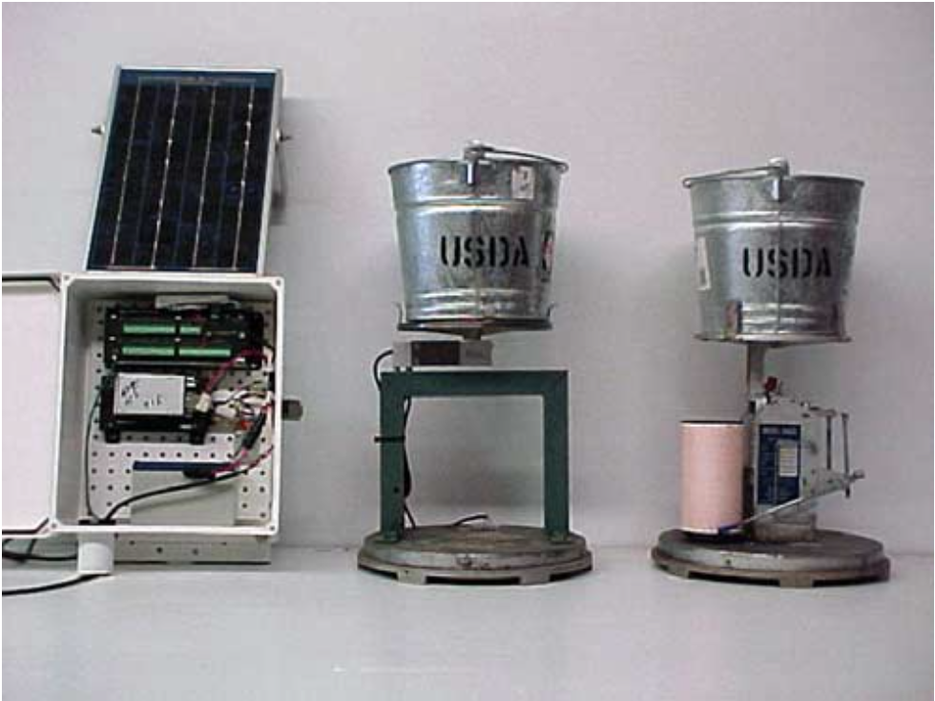
Figure 4: (Left) Digital rain gauge battery, telemetry, data logger, and solar panel. (Middle) Digital weighing rain gauge, strain gauge, and collection bucket. (Right) Belfort analog weighing rain gauge, mechanical linkage to pen arm and recording drum, and collection bucket. (WGEW Brochure)

After comparing various gauges on effectiveness and accuracy in the field, the WGEW* concluded that a digital weighing gauge was the most reliable in the face of a range of intensities in rainfall. From January 1st, 2000 onward, the data access is supplied by the digital weighing-recording network, which shows rainfall depths at 1min intervals during periods of rainfall. The analog data network continues to be referred to as well, though currently down to 9 gauges, and are either on or off for different periods of time, information which is indicated on the published records**.

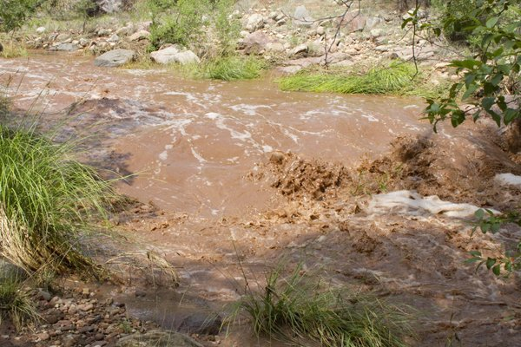
Figure 5: This is the result of three inches of rain in Payson, Arizona during a July monsoon. (Photo by Andy Towle)
Similarly to the rainfall gauges of the experimental watershed, a small number of flumes for measurement of runoff volume over the watershed were established in the early 1950s across the drainage basin. The runoff database from the watershed makes up the oldest recorded database of a semi-arid region in the world. The number of flumes has been built up from the five initial ones to a current total of 30. Also like the instrumentation for measuring precipitation, flume technology at the WGEW was upgraded from analog to digital in 1999, though both types are still used. (Goodrich, et al) Smaller watersheds throughout the greater watershed basin are equipped with channels to measure runoff of varying volumes.
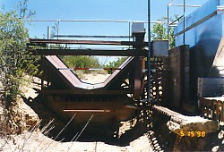
Figure 6: Smaller channel runoff measuring flume. Data on soil sediment is also taken as runoff passes through. (WGEW website)
Small watersheds were established to measure the interaction of rainfall intensity, soil sediment, vegetation, and management with the amount of runoff. Small watersheds are classified as such if between 0.0018-0.059km². Medium watersheds, 0.35-1.60km² in size, were established at small dams or stock tanks for measurements of storm runoff and annual sediment production. Finally, large watersheds, which range from 2.27-149km², show the effects of spatial and temporal variability in thunderstorm rain in regard to water yield, peak discharge, and sediment production.
Biodiversity research accompanied by authentic and unprocessed data is undoubtedly much harder to come by than similarly genuine meteorological data. The bulk of my difficulty with this paper originated in finding data I could personally process to correspond with trends in rainfall and soil absorption. Ultimately, the gem of a research article was one that assessed recent biodiversity in a semi-arid region across taxonomic levels with respect to proximity to riparian terrain, conveniently relevant to my research question. Further, this research was done along the San Pedro river between Sierra Vista and Tombstone, Arizona in the San Pedro Conservation Area, exactly where I had already found a bounty of precise and well-documented data on southeastern Arizona climate. To substantiate this source beyond its mere convenience in relation to the work I wanted to do, the work is peer-reviewed and was carried out by eight different authors from hydrology and water resources, biology, and life sciences departments of Arizona universities. The primary goal of this research article I’m using for the species diversity aspect of my paper was ‘to describe species richness, abundance, and community similarity patterns along a riparian to upland gradient in southeastern Arizona’.
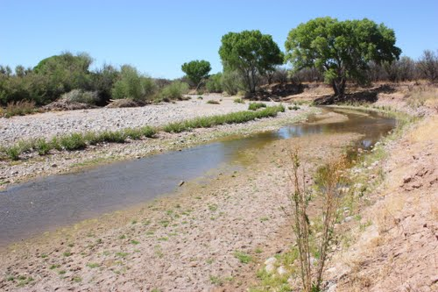
Figure 6: Bank of the San Pedro near Tombstone, Arizona (Taken from Google Earth)
The researchers observed species richness on a gradient of terrain from riparian to upland, classified as progressing through riverbed floodplain habitat, river terrace habitat, near desert scrub habitat, and far desert scrub habitat, respectively. (Soykan, et al) They sampled across multiple taxa found in the study area in order to illustrate as comprehensive as possible a perspective on the rangeland biodiversity. The research includes biodiversity of: forbs/grasses, shrubs, and trees; solpugids, spiders, and scarab beetles; butterflies; lizards; birds; small mammals; and mammalian carnivores. This data originated from unique and thoughtful approaches to accurate measurements of species richness, abundance, and similarity patterns across taxa and habitat gradient for each group of organisms.
To take data for grasses, shrubs and trees, the research committee established three 20m wide belt transects, 100m apart. These were each perpendicular to river drainage and spanned the width of the river floodplain, extending for 100m onto the river terrace on either side. Patches out of plots were randomly selected. They measured things such as tree stem size, percent cover within canopy, and sampled herbaceous cover during August, when biomass is highest. To take data for small mammals, the committee trapped specimen from a variety of locations using the transect method. The traps within each transect were, similarly to testing for plant species, randomly selected. Carnivorous mammals were recorded based on identification of foot prints with care not to record information from the same animal twice. Birds were recorded by identification through sight and sound. Overall, randomness of samples, consistency, and accurate identification were the main factors in the approach to taking data.
When discussing biodiversity from a scientific approach, it is important to note that by the definition of biodiversity itself, the variety of living organisms and the variability of their interactions, it is impossible to take conclusive, comprehensive, objective measurements. (Nautiyal, et al) The task is simply too great. Instead, biodiversity can be observed, to a certain degree, in relation to specific applications. (Natural History Museum, London) For the purpose of this paper, that application will be in relation to a range of terrestrial zones from riparian to dry. This follows along the intent of the research question aiming to understand the relationship between species diversity and overall dryness.

Results:
Refer to the appendix to see all data involved in the following results.

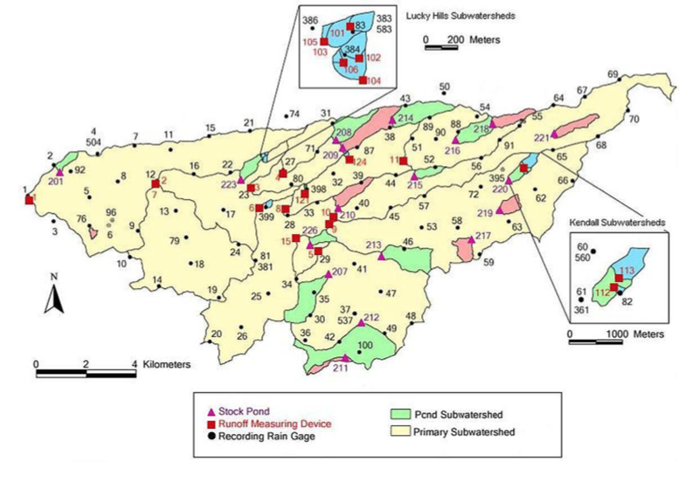d
Figure 7: Map of WGEW instrumentation (Nichols)
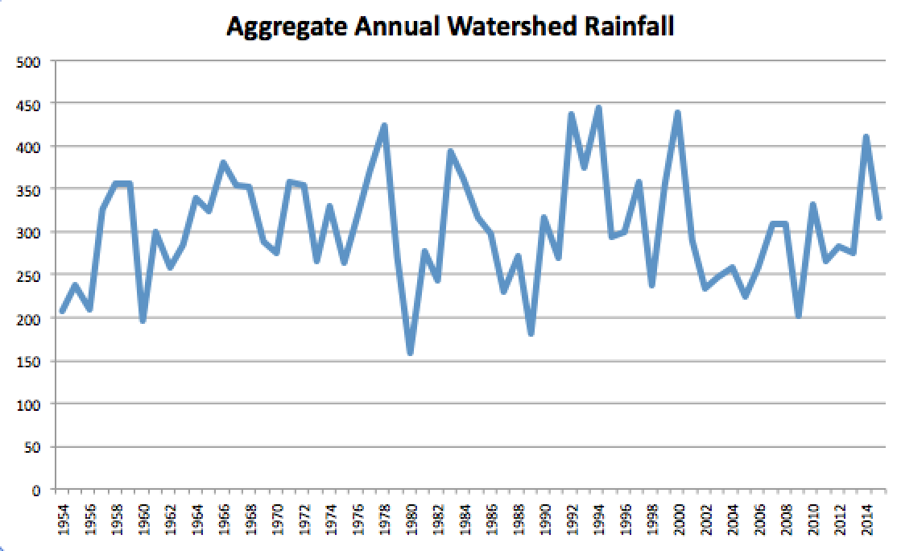
Figure 8: Trend in precipitation over the WGEW from 1954 through 2015, as interpreted from 88 analog and digital gauges (Appendix B)
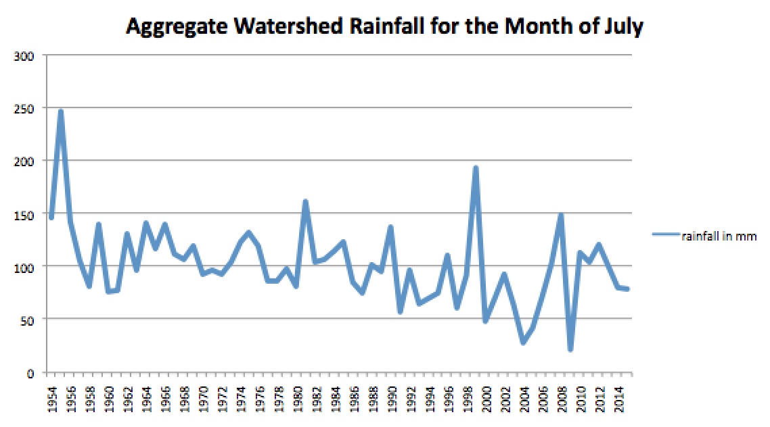
Figure 9: Annual July rainfall from 1954 through 2015 (Appendix C)
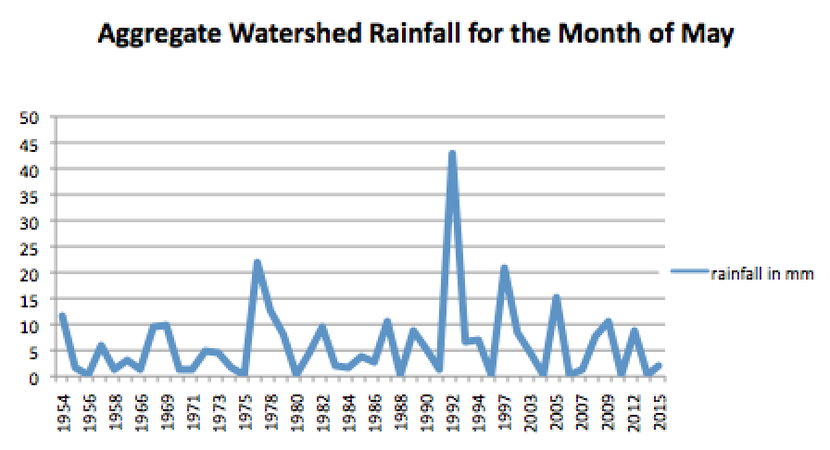
Figure 10: Annual May rainfall from 1954 through 2015
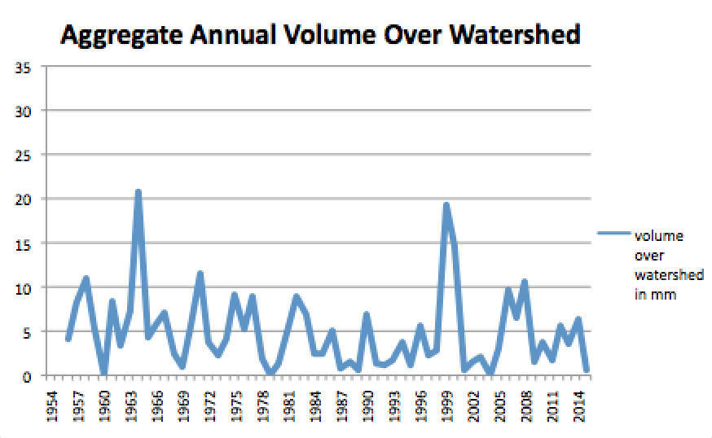
Figure 11: Annual total volume of water over watershed, interpreted from 15 flumes at different locations and of varying size. (Appendix D)

Species richness according to habitat type
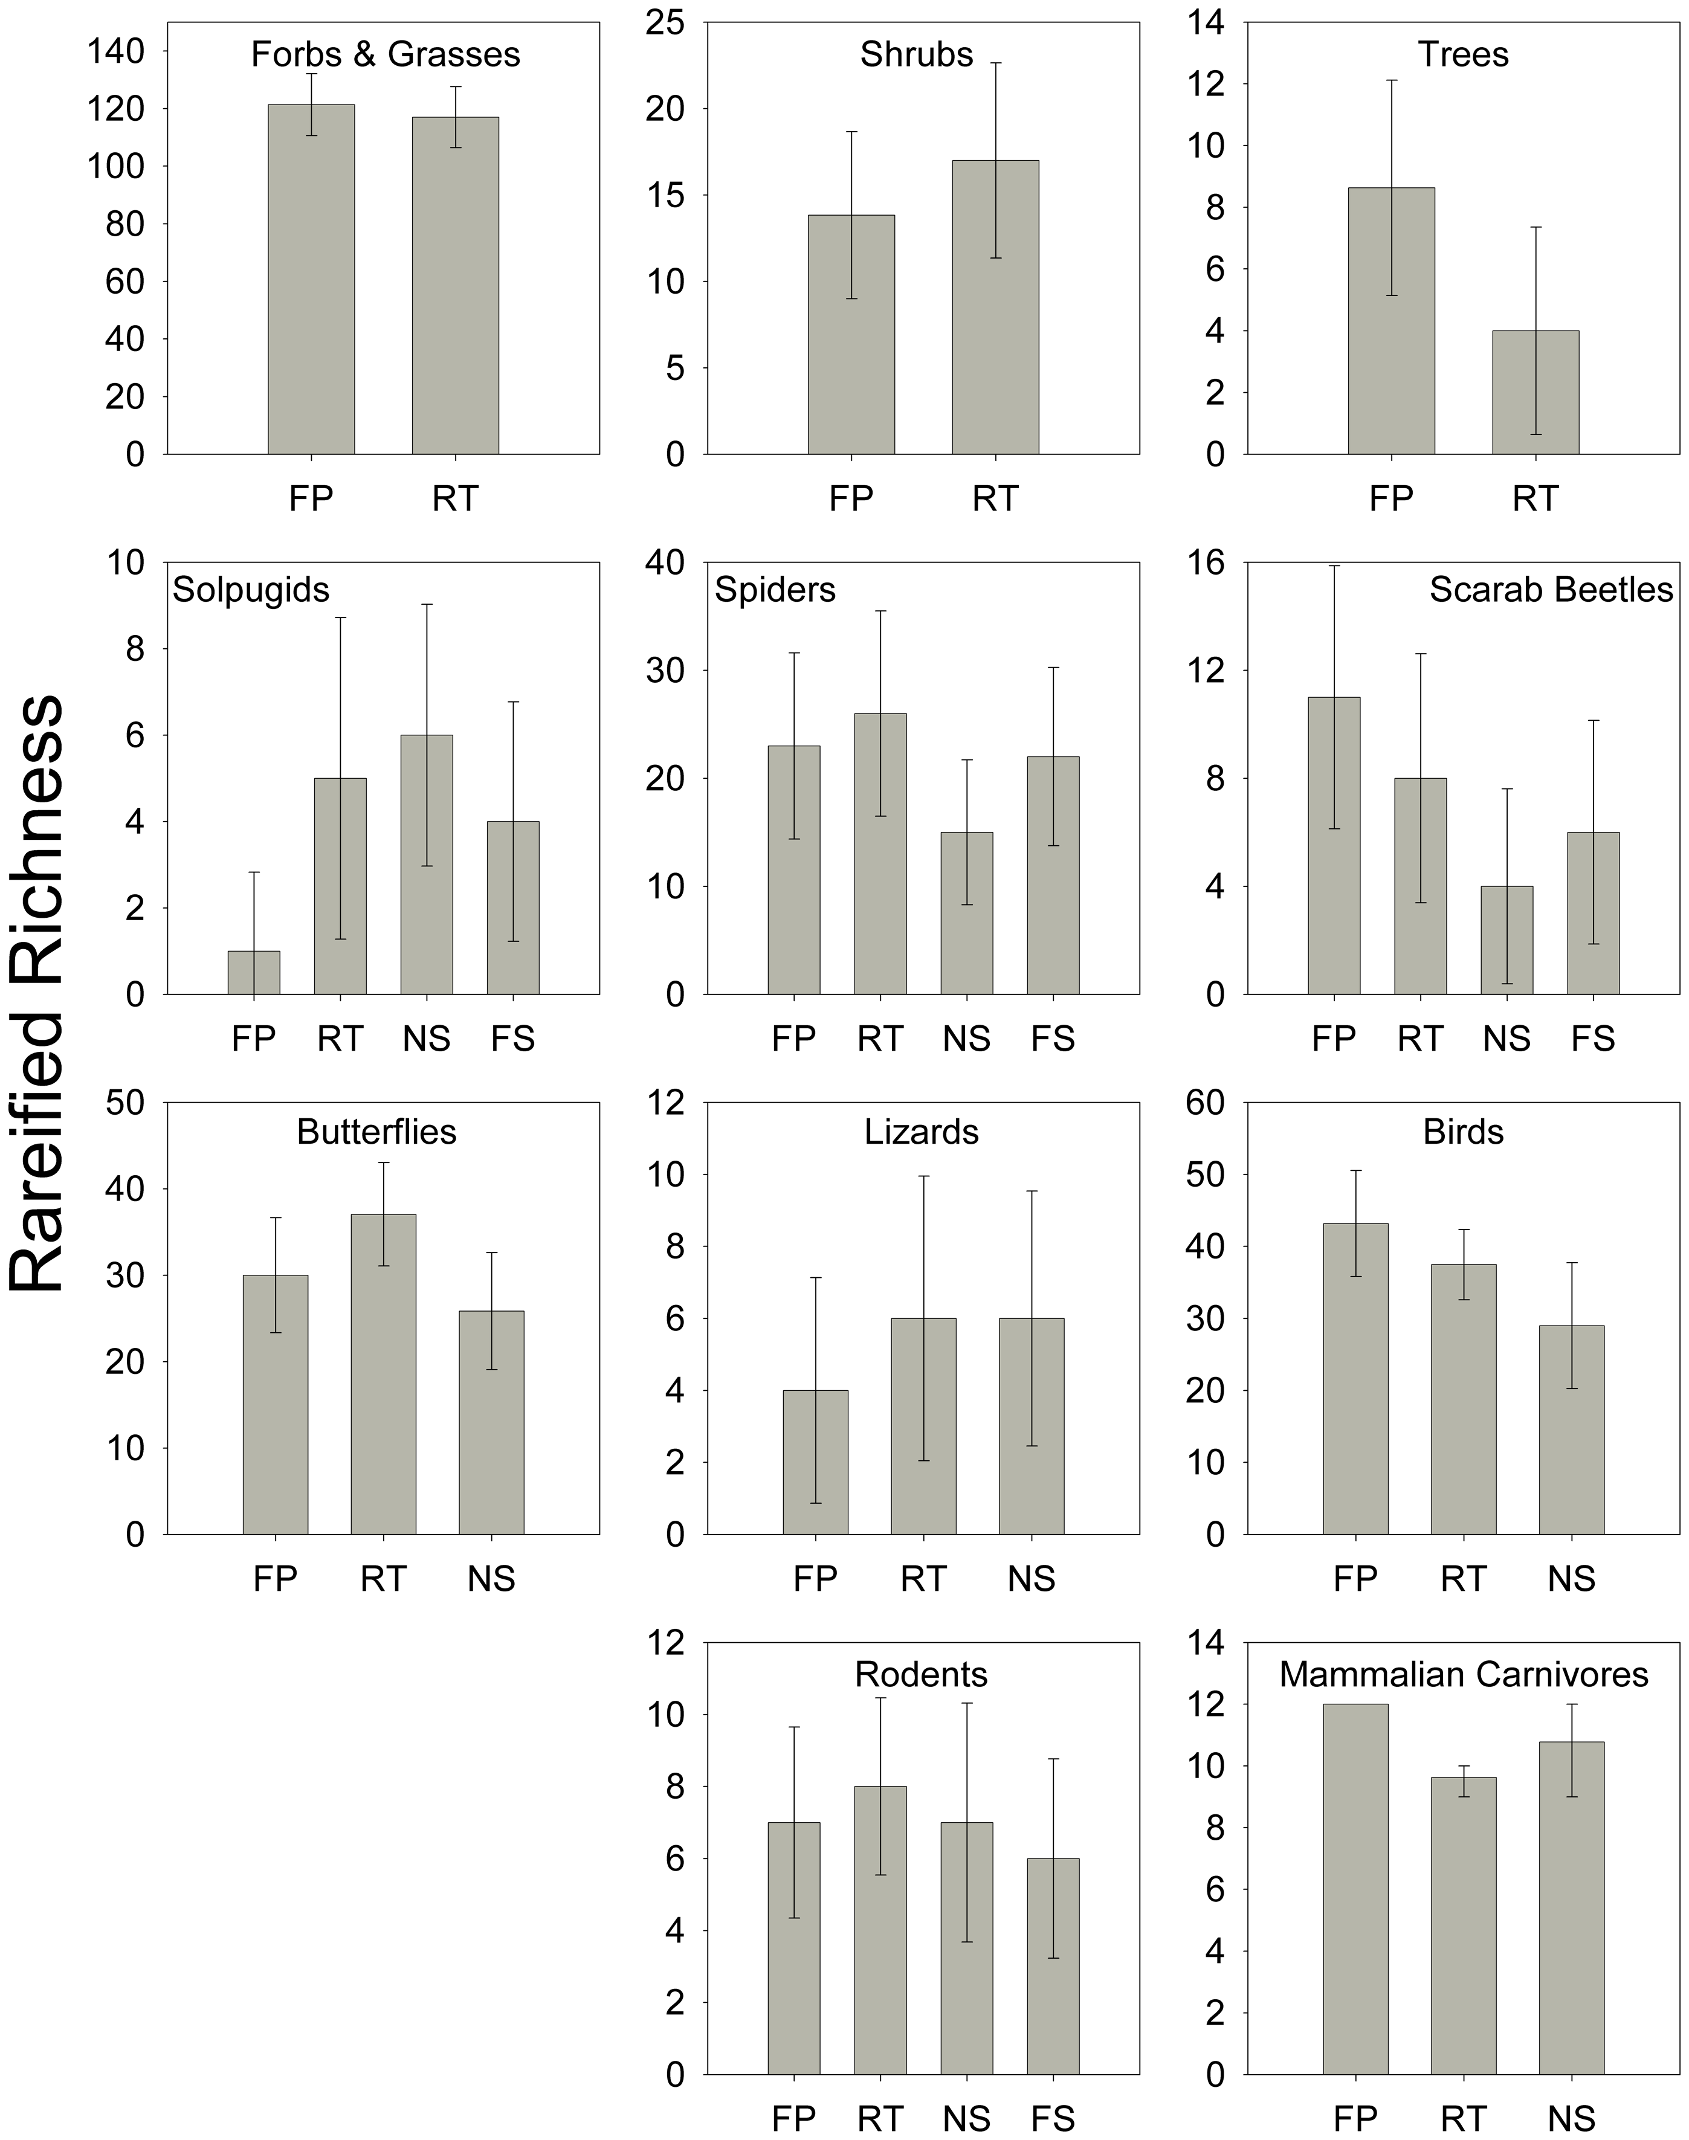
Figure 12: Observed patterns in location based on habitat gradient (Appendix A)
FP = floodplain habitat
RT = river terrace
NS = near-river desert scrub
FS = desert scrub far from the river
Species abundance according to habitat type
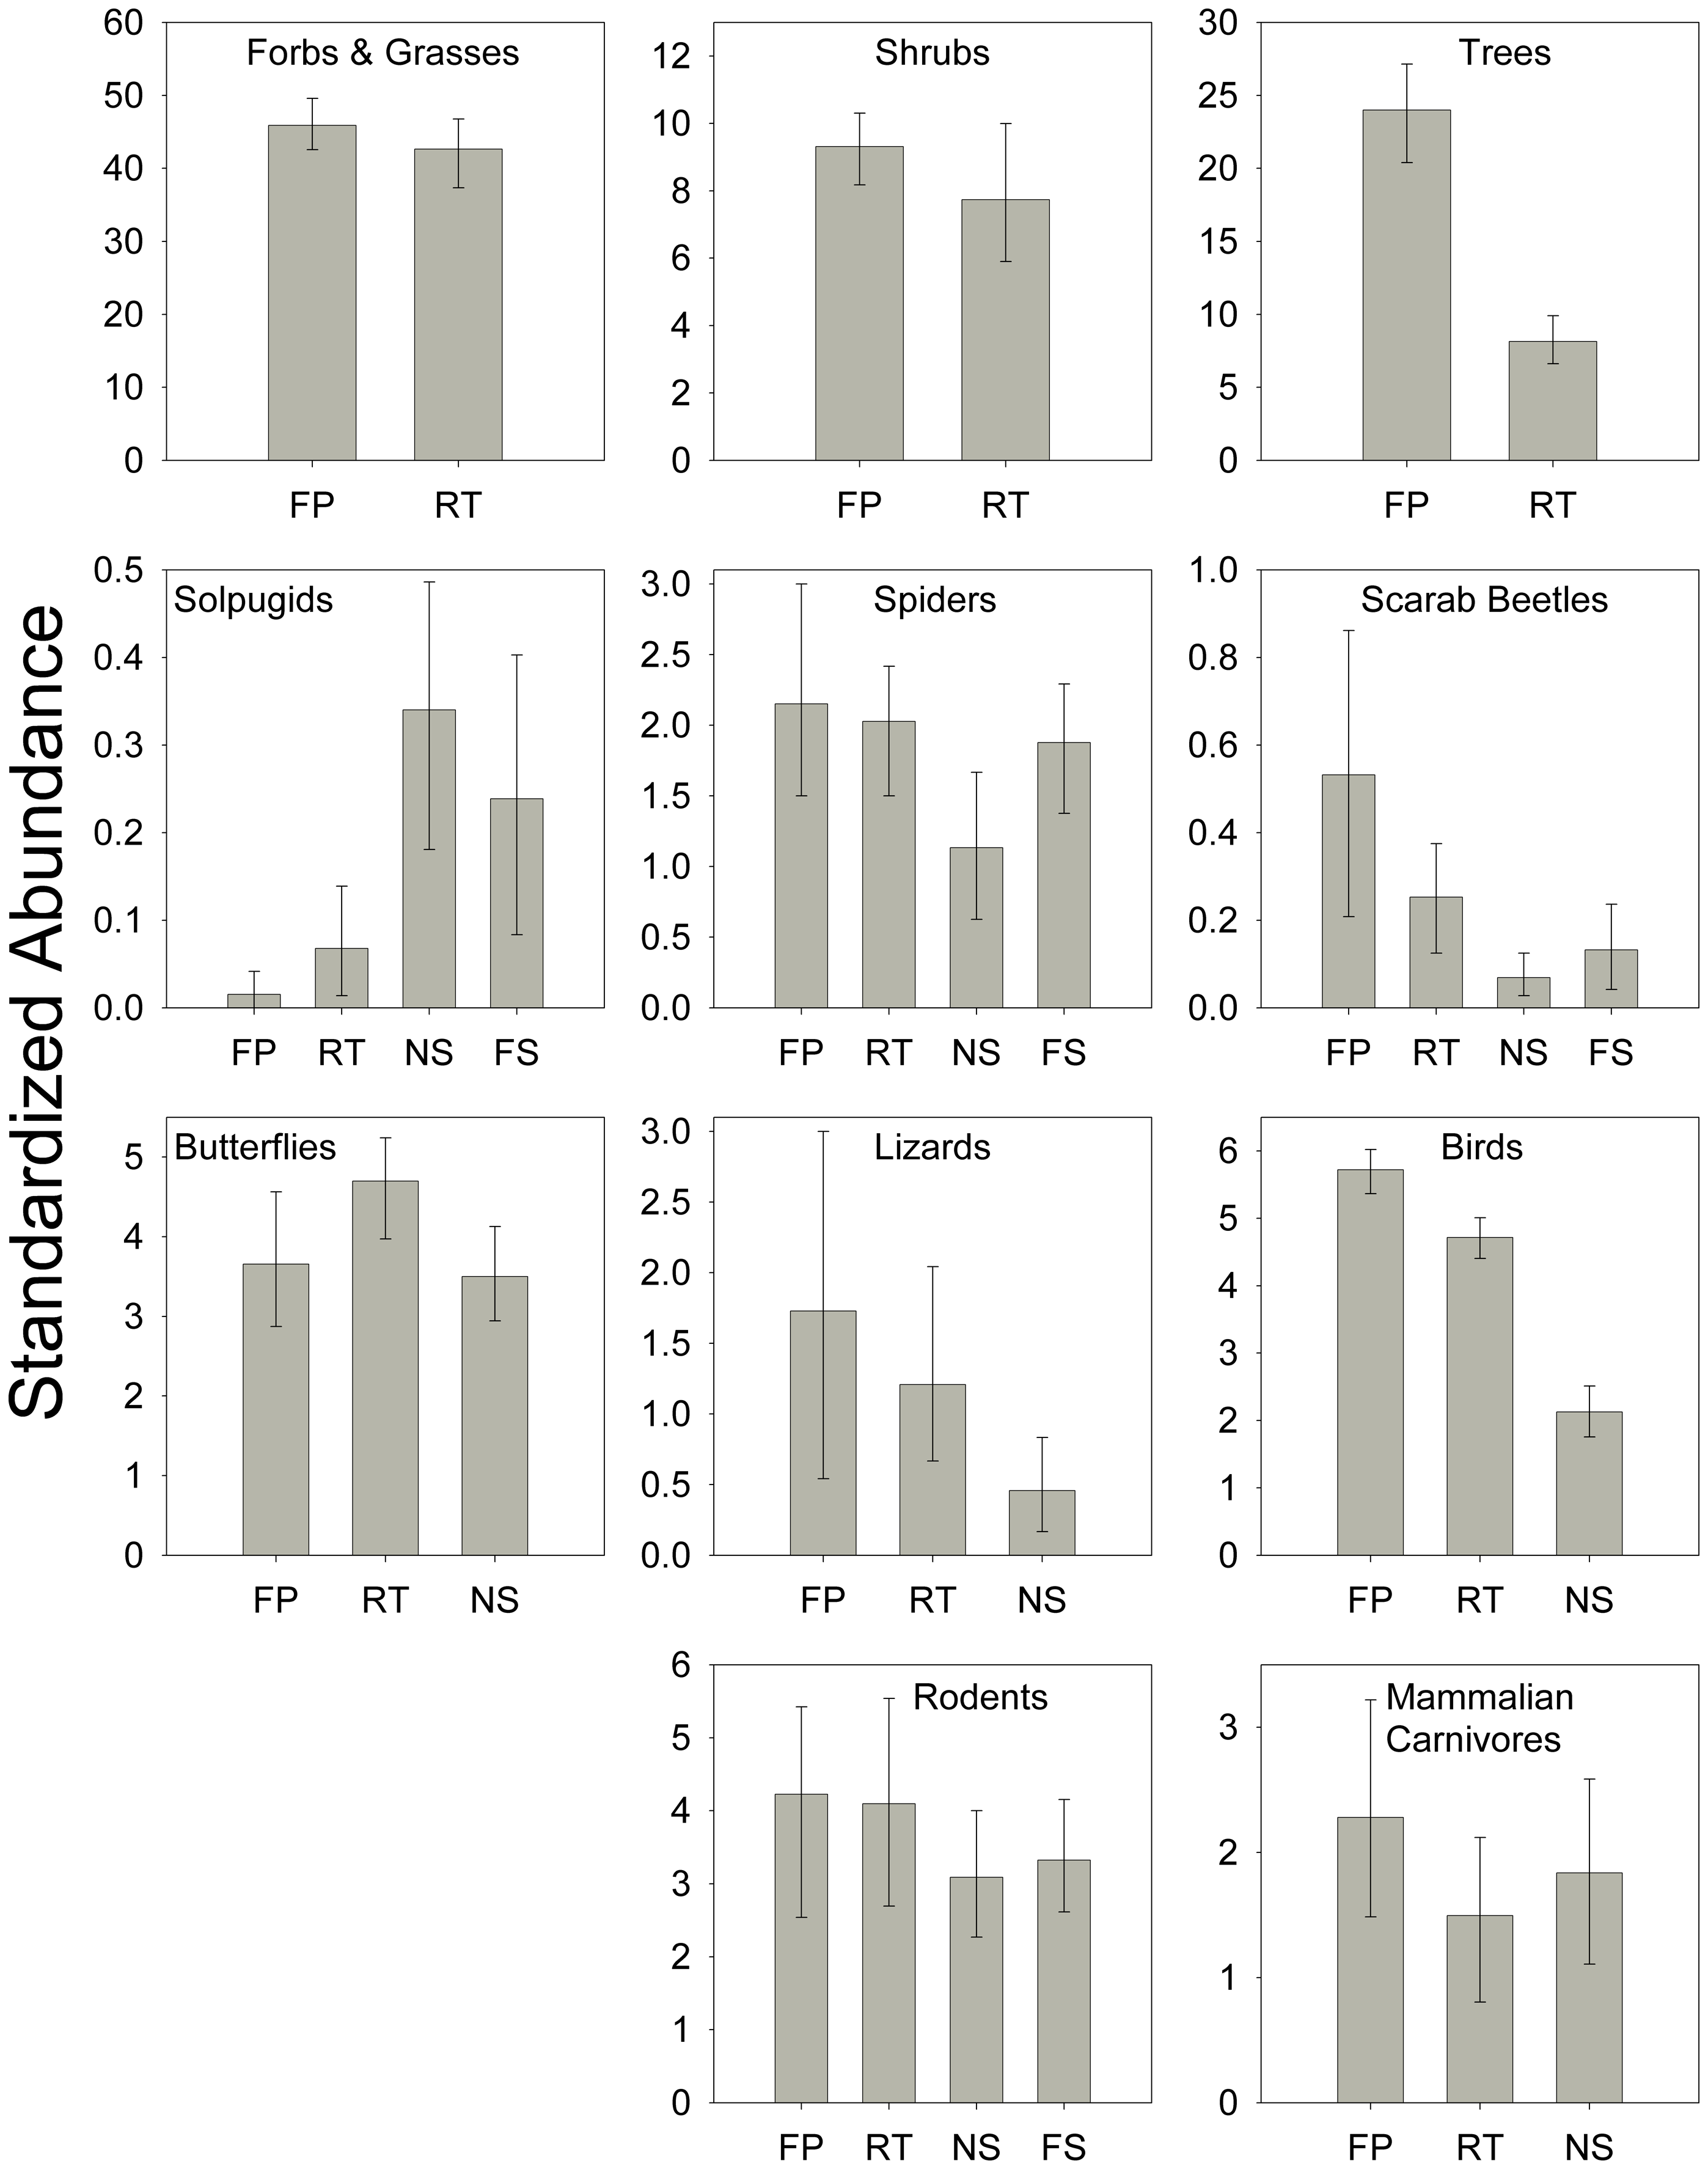

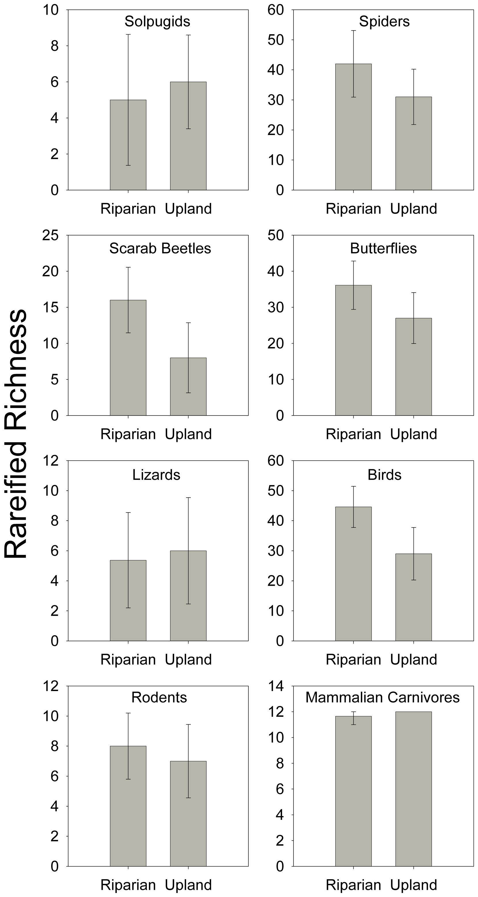
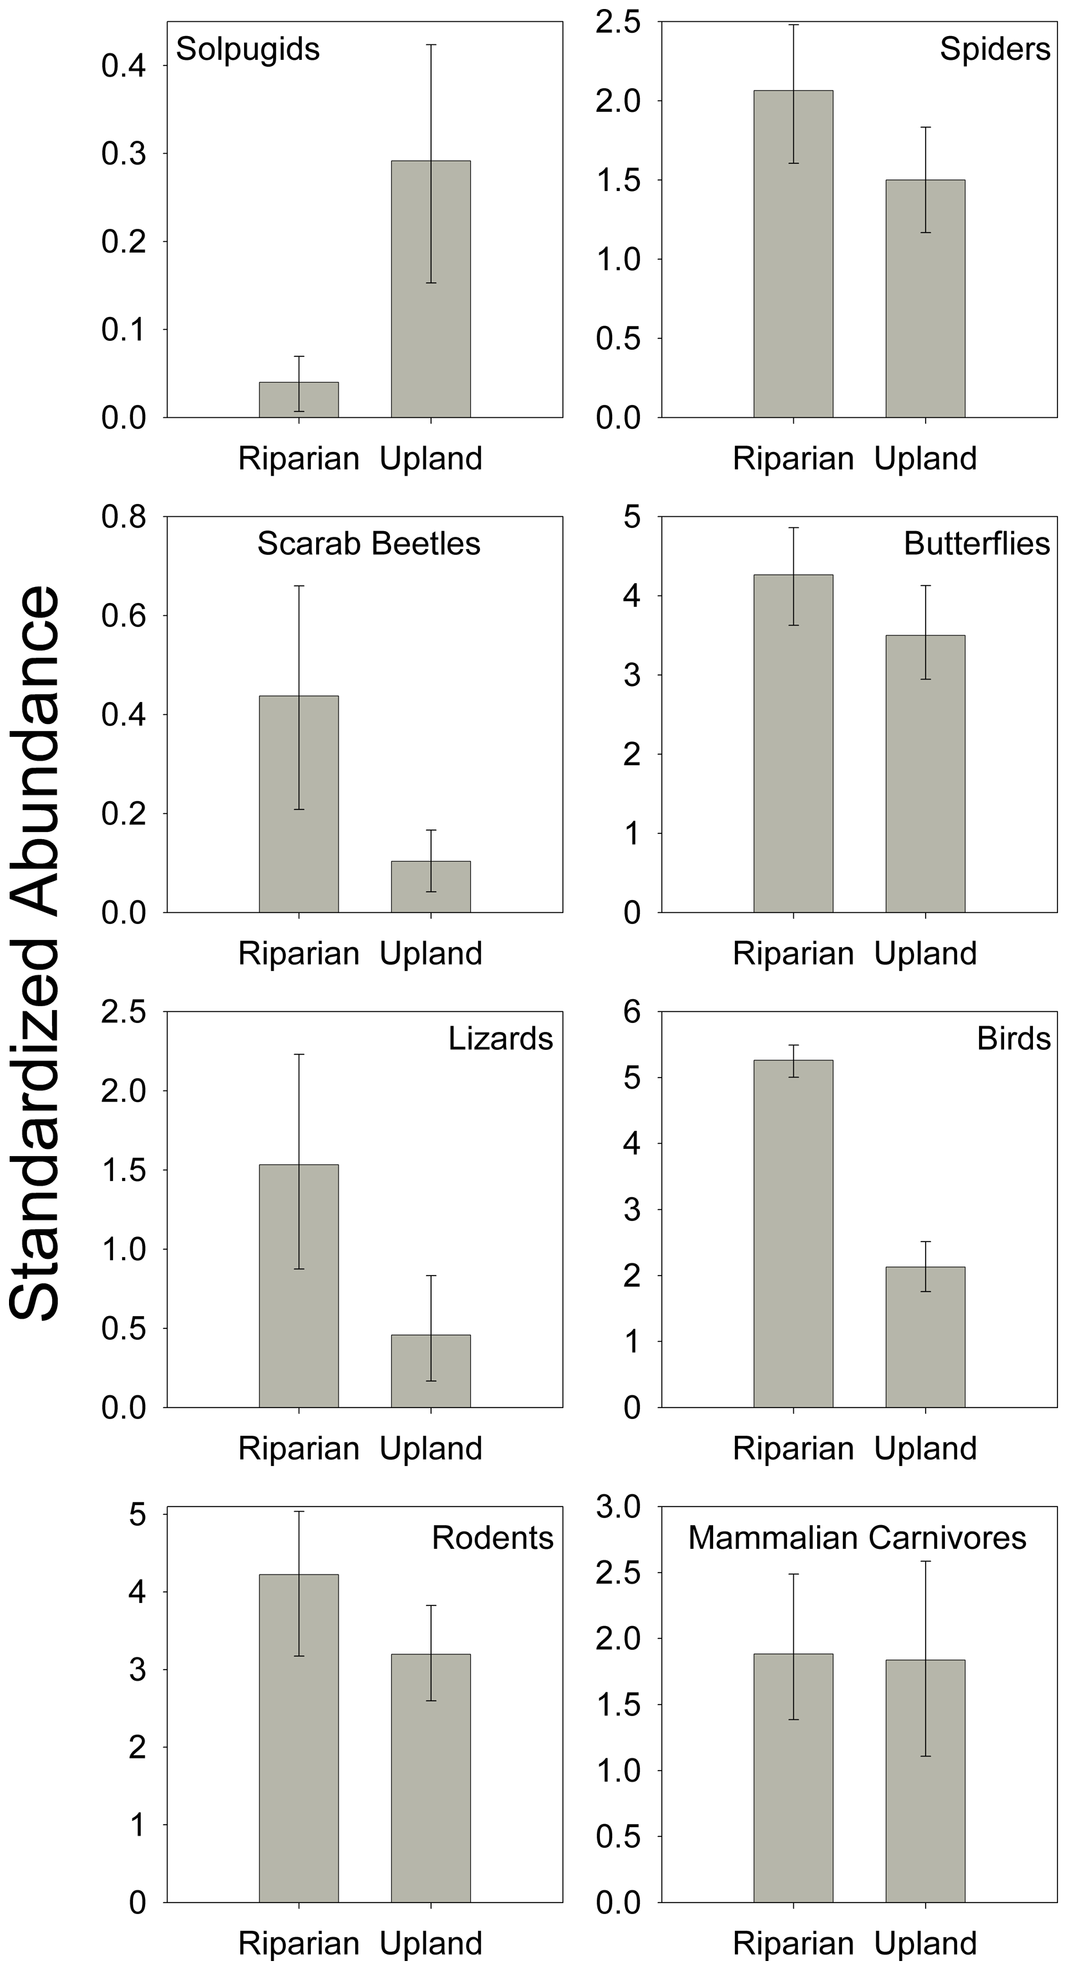
Species abundance and richness according to habitat zones

Analysis:
Annual aggregate precipitation throughout the Walnut Gulch Experimental Watershed revealed neither a clear incline or decline over the past sixty years. Precipitation ranged in depths in gages from 158.712mm in 1980 to 444.755mm in 1994 and varied a lot from year to year, slightly increasing over time.
In southeastern Arizona, July has the greatest amount of rainfall by comparison to all other months in the year. The southwest experiences great monsoons during the months of July, August, and September, then rainfall slows down significantly over the fall and winter before being almost completely non-existent in the months before the monsoon. I used data from the research center data access site to observe any precipitation patterns in July, the most extreme month for rain, for each of the past sixty years. Similarly to aggregate annual rainfall, precipitation in July varies quite a lot year to year. However, unlike aggregate annual rainfall, the amount of precipitation in July has been decreasing. The first recorded average amount of precipitation across rainfall gages was 145mm, while the most recently recorded amount is 78mm.
May has the lowest amount of rainfall in relation to all other months in Arizona, with an average total rainfall of 6.13mm compared with July’s 101mm. Graphing the data on aggregate precipitation from May for the past sixty years failed to result in any clear pattern, rising or declining. It did reveal that the amount of rain in May has increased in variability from one year to the next. Additionally, the lowest amount of May rainfall from all of the past sixty years was only two years ago, while the first recorded amount from 1954 was one of only six times the aggregate precipitation reached over 10mm, indicating there is perhaps a slight downward trend in addition to the trend towards more variability. The greatest recorded aggregate rainfall from the observed period of time was 42.9mm in 1992, while the lowest was 0.25mm in 2013. The most recently recorded amount is 1.97mm.
The volume of water over measured watersheds also failed to reveal any strong patterns over time, but did slightly decrease as the first recorded volume was 4.12mm³ while the most recently recorded volume is 0.65mm³. However, there were two large spikes in total runoff during the observed time, reaching to 20.76mm³ in 1964 and to 19.3mm³ in 1999. The lowest recorded volume of runoff was in the most recent fourth of the observed period of time at 0.03mm³ in 2004.
Species richness and abundance are relatively significantly skewed towards riparian habitats. Six taxa have higher species richness in the river floodplain, closest to the river; forbs and grasses, trees, beetles, birds, and mammalian carnivores. Four taxa have a higher richness in the river terrace, second closest to the river; shrubs, spiders, butterflies, and rodents. Solpugids and lizards have a higher species richness in the near shrub-desert habitat. Further, trees and birds were found to be significantly more abundant in the river floodplain than any other habitat type. Forbs and grasses, shrubs, spiders, beetles, lizards, rodents, and mammalian carnivores were also most abundant in the river floodplain, but less significantly.
In regard to riparian vs upland zones, five of eight taxonomic groups had higher richness in riparian zones; spiders, beetles, butterflies, birds, and rodents. Solpugids, lizards, and mammalian carnivores had higher richness in upland zones. Three groups, beetles, lizards, and birds, were statistically significantly more abundant in riparian than upland zones. Four other groups, spiders, butterflies, rodents, and mammalian carnivores were also most abundant in riparian zones instead of upland zones, but less significantly.
The WGEW Research Center turns off different gauges for different intervals in order to perform maintenance. Information on the periods of time for which certain gages are inactive is included in the data, listed as dates on or off for each gage. This information is repeated throughout the numerical precipitation data as zeros for whichever years the gage was inactive. However, zeros were also listed for whenever the gage was active but there was no recorded precipitation for that point in time. This likely affected the data because I omitted any zeros in calculating averages of the total collected rainfall across all 88 gages to avoid counting data from an inactive rainfall gage. Therefore, the graphs I made may show higher amounts of precipitation than there actually was. This same issue arose in runoff measuring flumes, as some of those were shut off for maintenance at varying intervals. Also, some gages and flumes were discontinued completely, accounting for some gaps between gage or flume number, and reducing the total pool of data for some years.

Conclusion:
Significant research has been done to show that drought is occurring more frequently since the overall increase in CO₂ over the past century. However, drought is not a definitive term and must be considered relative to the region where it is occurring. Drought in semi-arid regions is the result of different factors than drought in regions of different climactic features. Further, drought cannot be easily quantified, recorded, and visually portrayed through a neat and clear graphical trend. Drought is the result of too many different variables for this to be possible. Therefore, the approximately flat trend in amount of precipitation does not mean southeastern Arizona has not been experiencing drought. Instead, climate change produces drought and other adverse conditions by increasing the volatility of the region. This means that instead of relatively consistently large amounts of rainfall during the monsoon season and small amounts of rainfall during the dry season, there will be more variability between one year and the next. The increased CO₂ concentration in the atmosphere causes erratic weather patterns and un-seasonal rain or dryness. This too makes drought hard to quantify, as it results from unusual conditions, not necessarily simply dryer dry seasons.
Evapotransportation is another factor of drought, accounting for the rate of evaporation of water from the ground. (National Oceanic And Atmospheric Association) However, for the purpose of narrowed scope in this paper, I chose to eliminate this from consideration. I instead have focused on the amount of rainfall and the amount that it accumulates without being absorbed into the ground. More advanced research on this topic often does include trends in evapotransportation of arid regions, which could help in revealing a clearer pattern in climate change.
Further dryness is a threat to the future of the San Pedro River, and thus a threat to the greater abundance of species nearer the river bed than the shrub-land desert. Across the western part of the country, as average yearly temperature increases, there are river beds that go dry for longer periods of time. Unless carbon emissions are radically reduced, this trend will likely progress towards the elimination of tributaries towards rivers and their watersheds, such as the WGEW, and eventually of the main rivers themselves. As evidenced by the greater abundance and species richness at the riparian interface closest to the water, active rivers are very important for the overall biodiversity of semi-arid regions.
In conclusion, trends in precipitation and runoff affect species richness to the extent that they threaten sustainability of rivers and river ecosystems. However, I did not find a clear correlation between trends in recent precipitation or runoff over the watershed that I observed and increased drought conditions. There is a distinct correlation between regional biodiversity and proximity to the San Pedro River, indicating that biodiversity of many southeastern Arizonan taxa is greater closer to the river. Therefore, as climate change progresses, furthering volatile climactic conditions that lead to prolonged dryness, biodiversity is likely to decrease.

Works Cited:
- "Biodiversity and WorldMap." MEASURING BIODIVERSITY. The Trustees of the Natural History Museum, London, n.d. Web. 13 Dec. 2015.
- Chapin, F. Stuart, Osvaldo E. Sala, and Elisabeth Huber-Sannwald. Global Biodiversity in a Changing Environment: Scenarios for the 21st Century. New York: Springer, 2001. Print.
- "Climate of 2013 - April U.S. Standardized Precipitation Index." U.S. Standardized Precipitation Index. National Oceanic And Atmospheric Administration, 15 May 2013. Web. 18 Dec. 2015.
- DeBarry,Paul A. (2004). Watersheds: Processes, Assessment and Management. John Wiley & Sons.
- Goodrich, David C., Timothy O. Keefer, Carl L. Unkrich, Mary H. Nichols, Herbert B. Osborn, Jeff J. Stone, and John R. Smith. "Long-term Precipitation Database, Walnut Gulch Experimental Watershed, Arizona, United States." Water Resources Research Water Resour. Res. 44.5 (2008): n. pag. Wiley Online Library. John Wiley & Sons, Inc. Web.
- Marvier, Michelle A. “Biodiversity.” AccessScience. McGraw-Hill Education, 2014. Web. 9 Dec. 2015.
- McNab, Alan L., and Thomas R. Karl. "Climate and Droughts." Climate and Droughts. National Oceanic And Atmospheric Administration, 5 Aug. 2013. Web. 2015.
- Nautiyal, Sunil, Katari Bhaskar, and Y. D. Imran. Khan. Biodiversity of Semiarid Landscape: Baseline Study for Understanding the Impact of Human Development on Ecosystems. Cham: Springer, 2015. Print.
- Nichols, M. H., and K. G. Renard. SEDIMENT RESEARCH AND MONITORING AT THE USDA-ARS WALNUT GULCH EXPERIMENTAL WATERSHED (n.d.): n. pag. USGS. Southwest Watershed Research Center. Web.
- Peel MC, Finlayson BL & McMahon TA (2007), Updated world map of the Köppen-Geiger climate classification, Hydrol. Earth Syst. Sci., 11, 1633-1644.
- Ponce, Victor M., Raul V. Cardoso, and Thalia G. Arredondo. "Drought Facts, Drought, Drought Mitigation, Drought Preparedness, Drought Impacts, Drought Characteristics." Drought. Ojos Negros Research Group, n.d. Web. 12 Dec. 2015.
- Soykan CU, Brand LA, Ries L, Stromberg JC, Hass C, et al. (2012) Multitaxonomic Diversity Patterns along a Desert Riparian–Upland Gradient. PLoS ONE 7(1): e28235. doi: 10.1371/journal.pone.0028235

Appendices:
Appendix A
Species Count
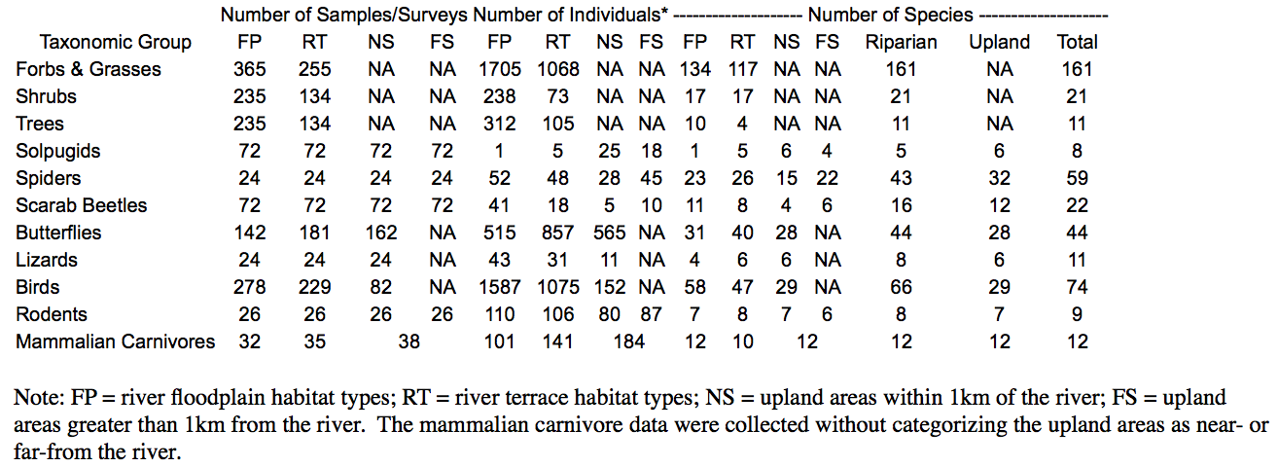
(Soykan, et al)

Appendix B
Annual Precipitation
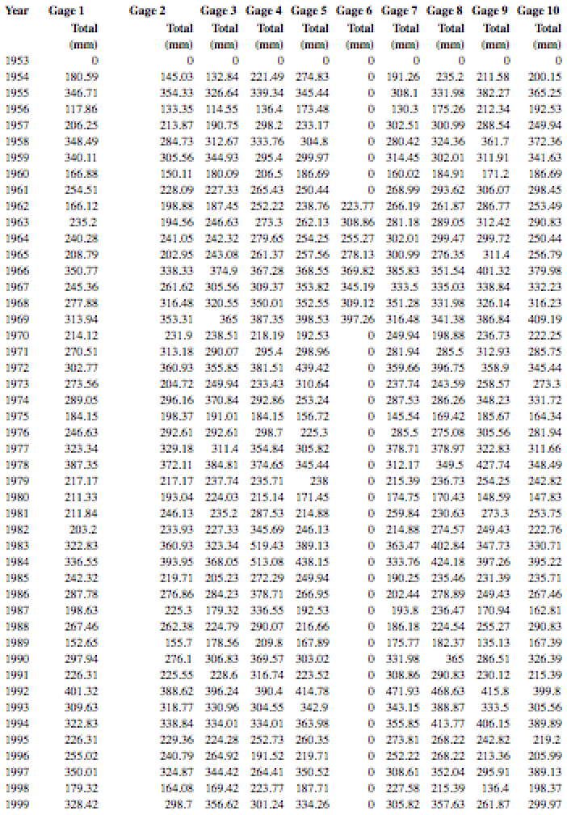
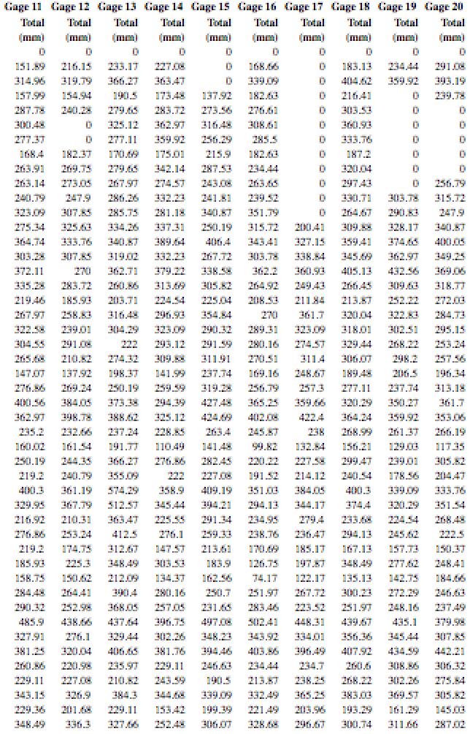
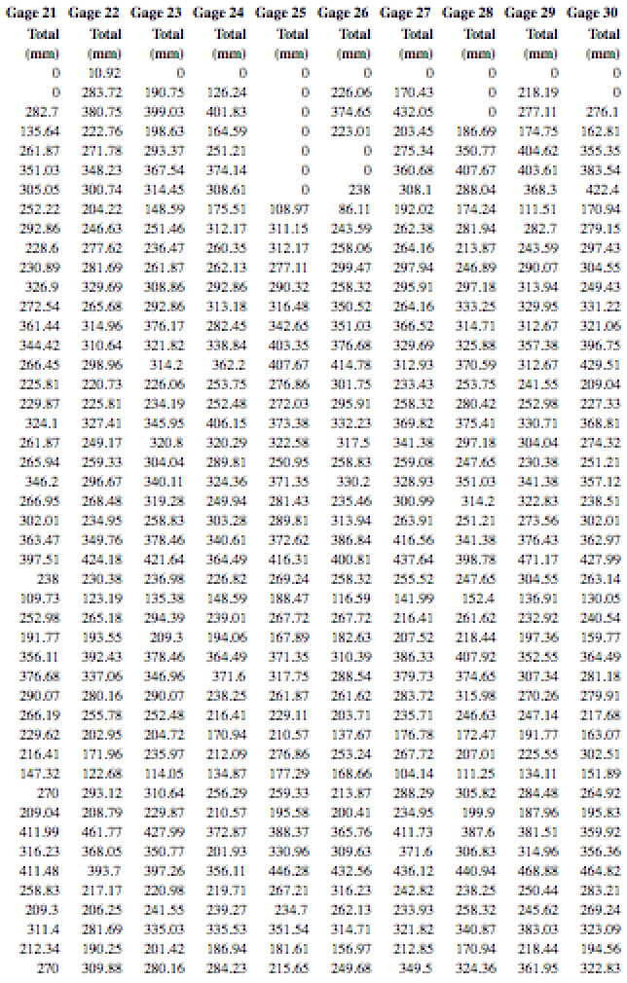
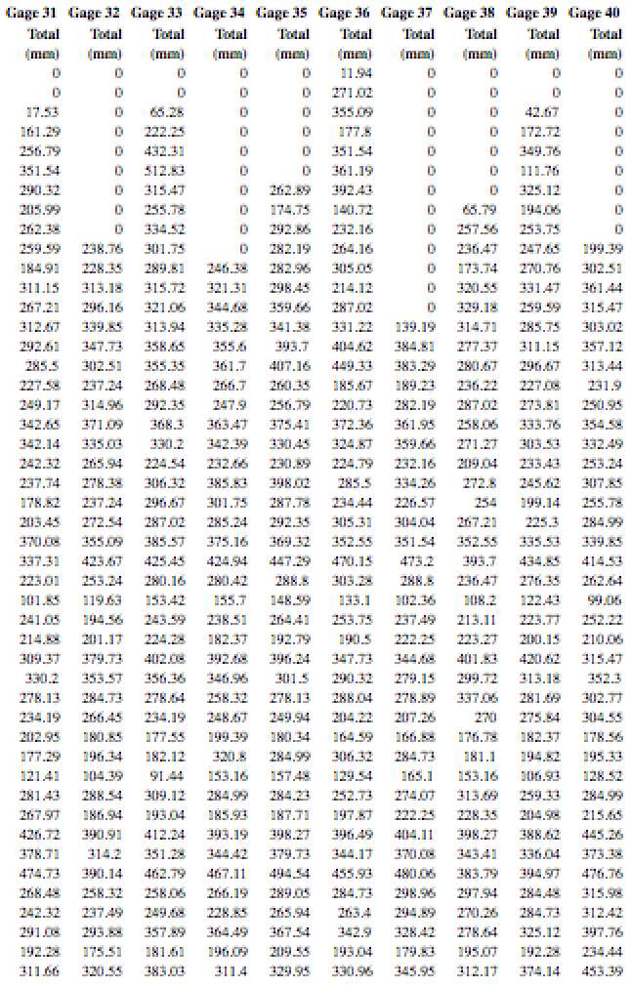
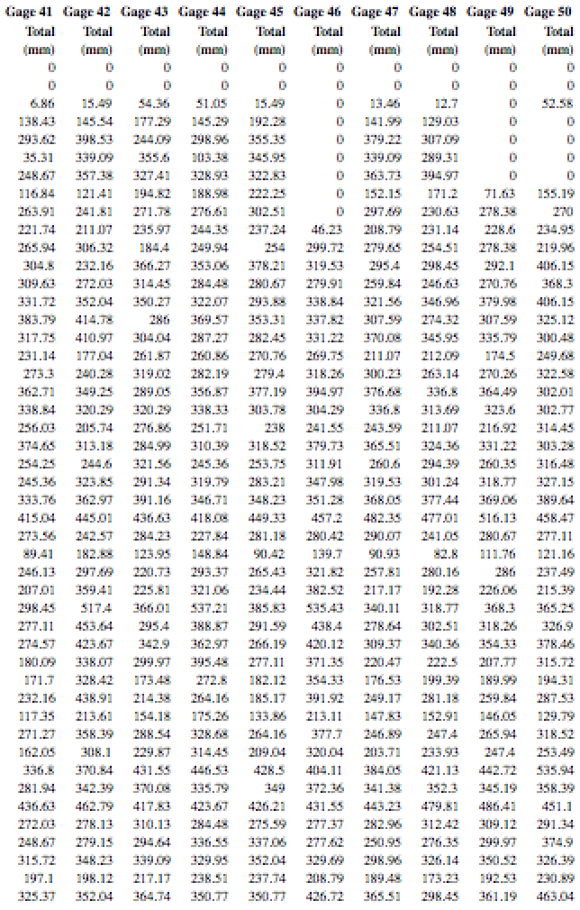
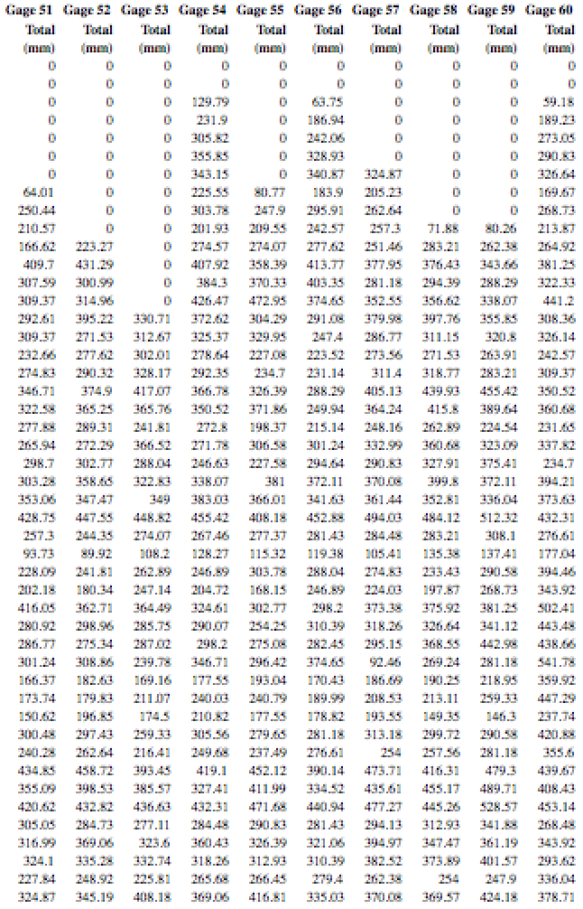
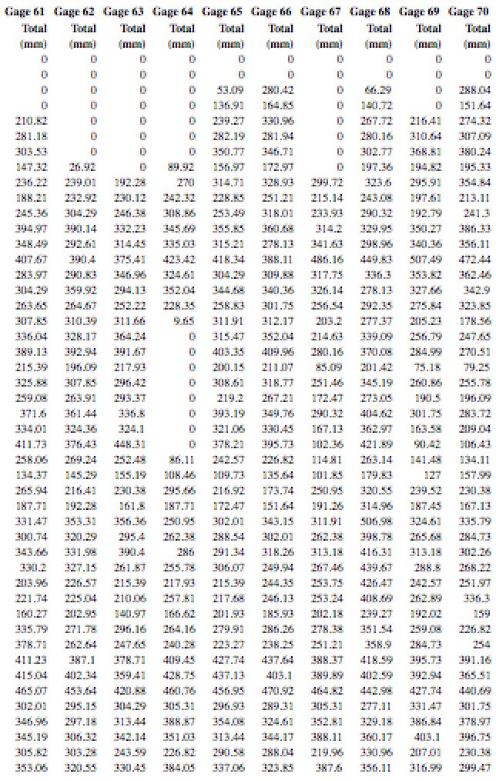
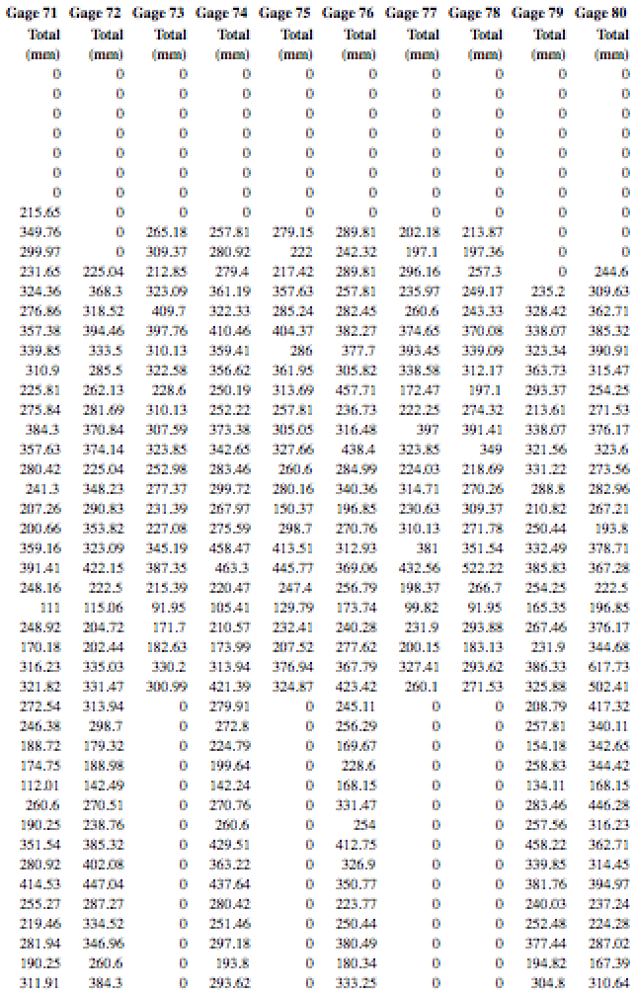
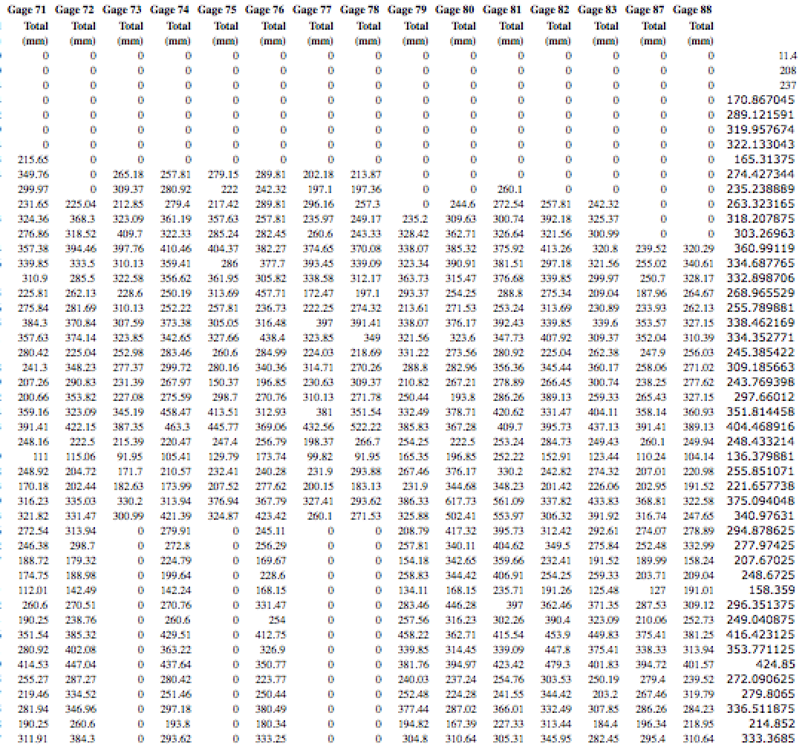
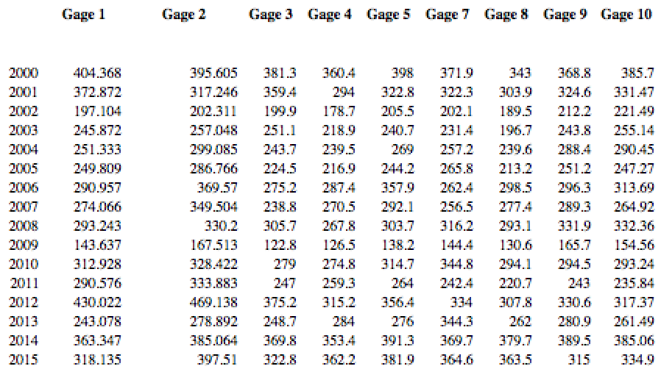
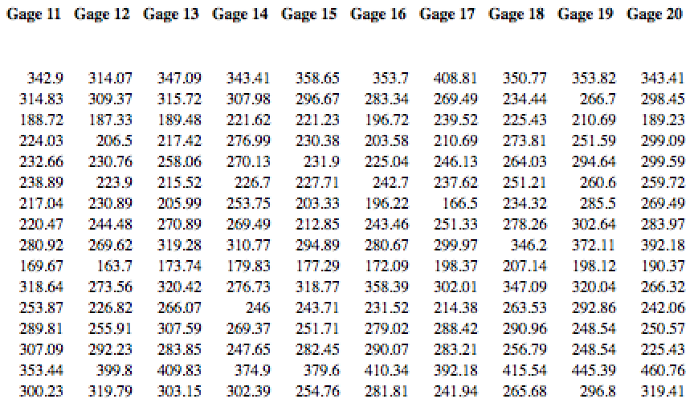
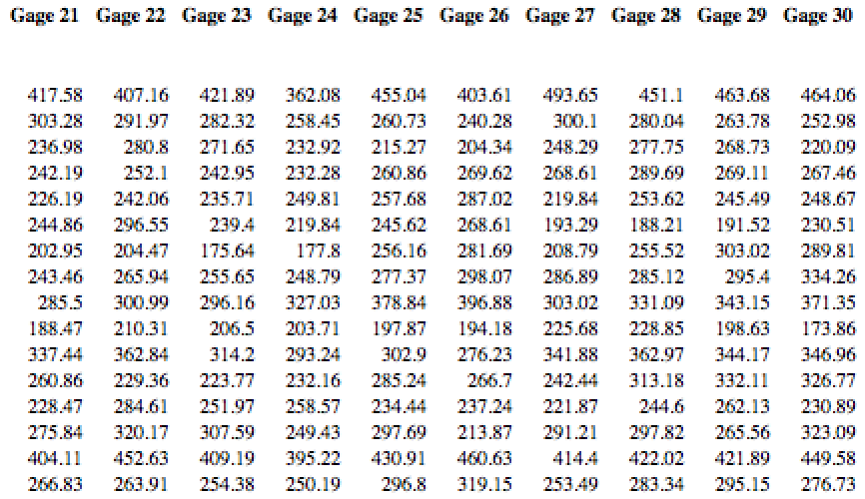
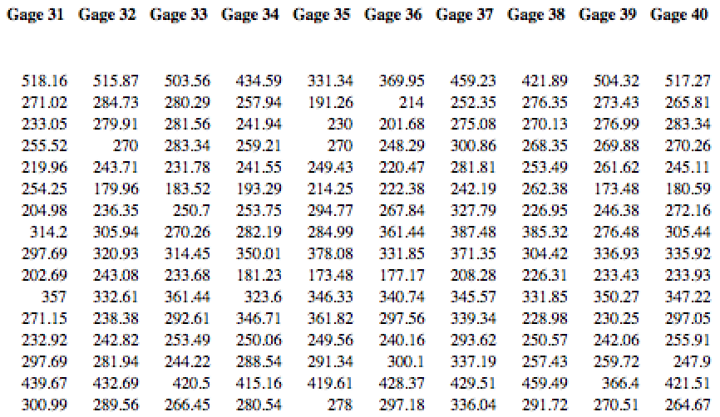
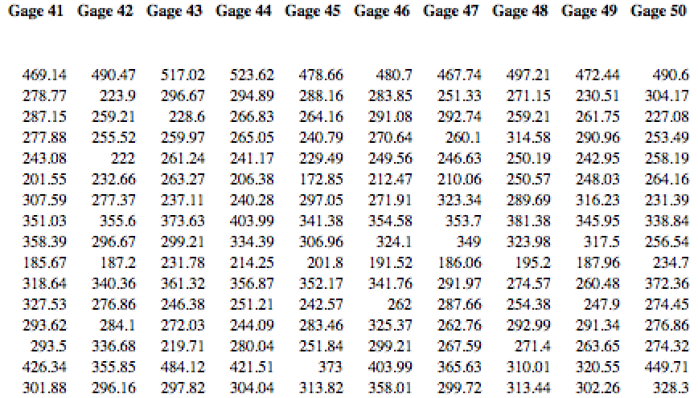
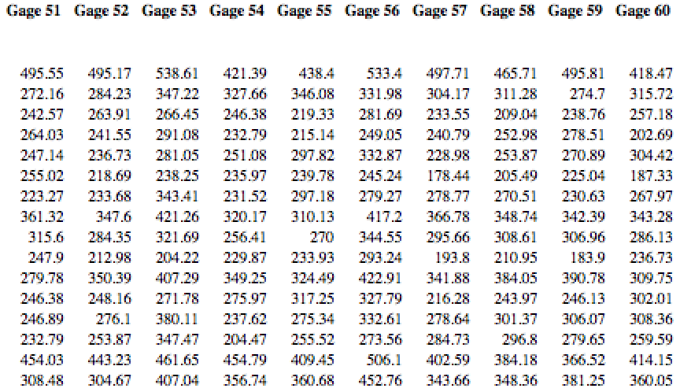
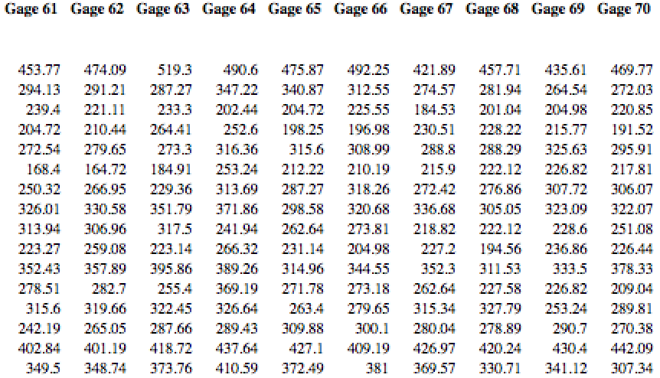
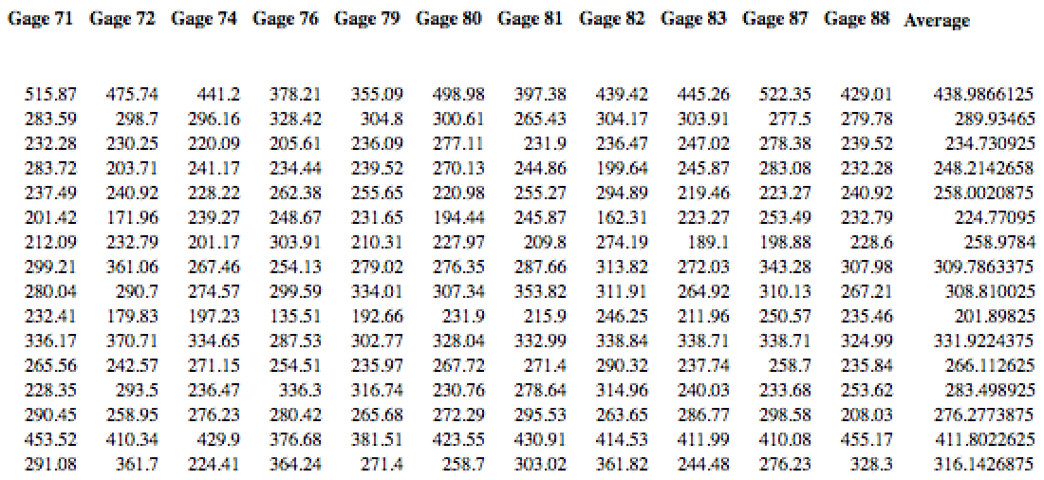

Appendix C
Yearly July Precipitation
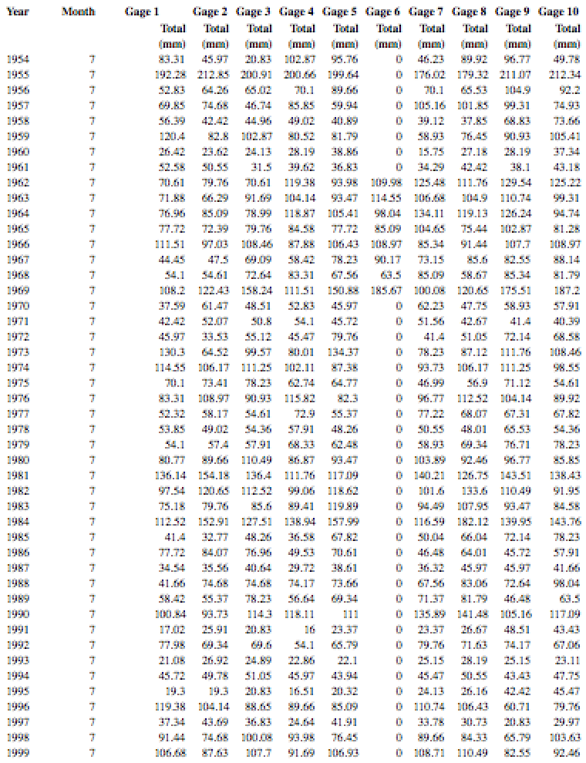
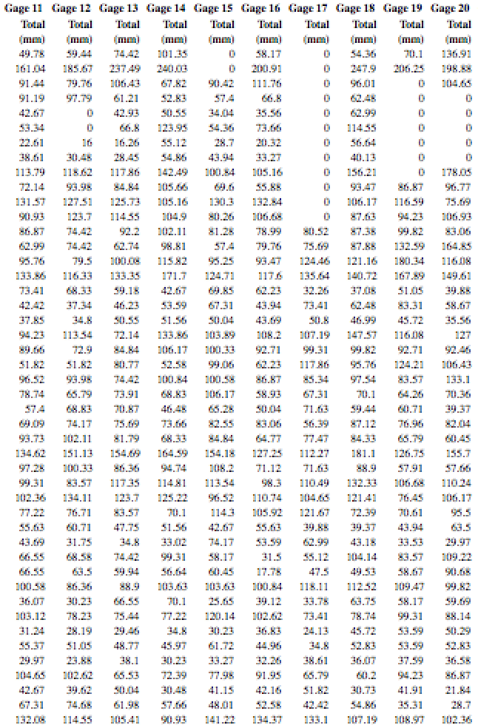
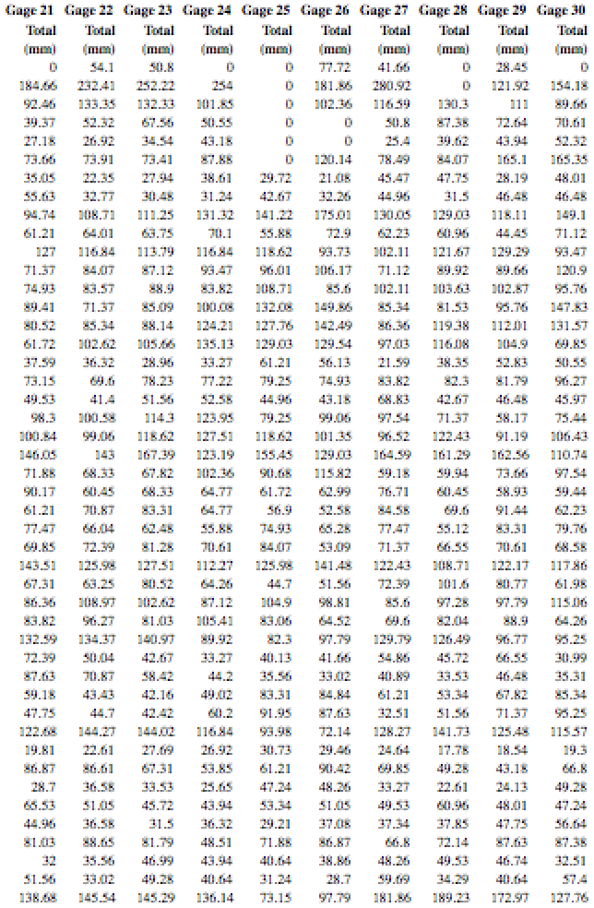
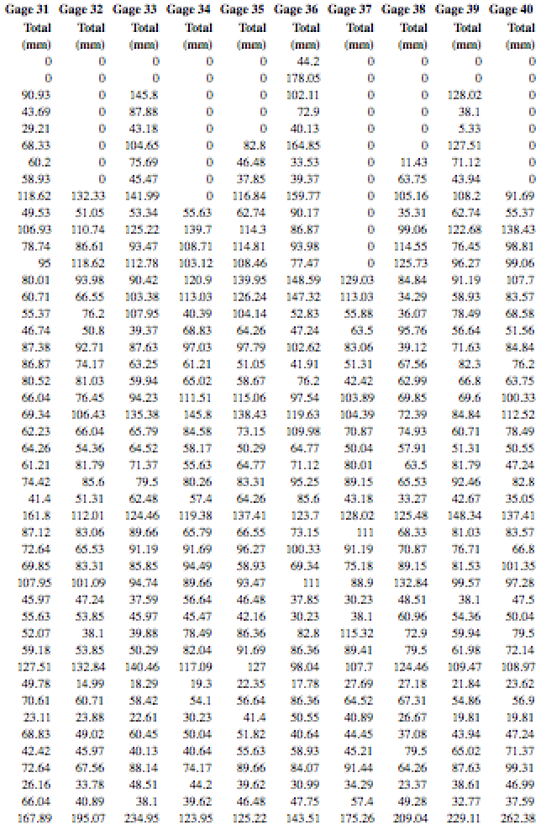
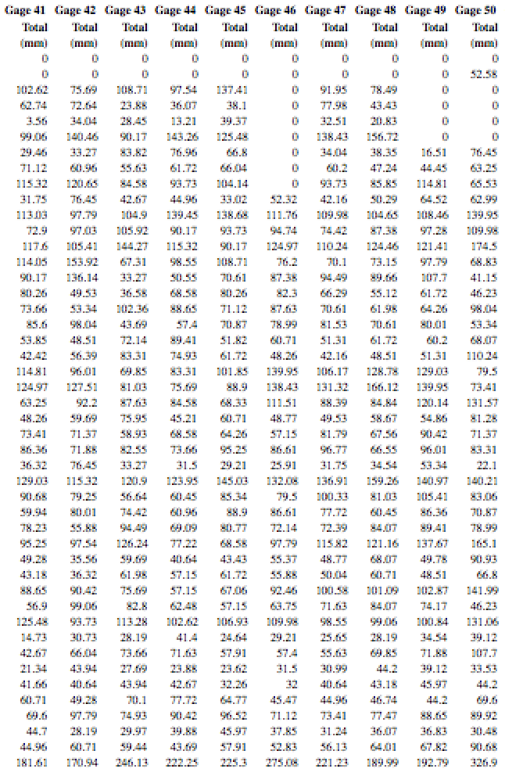

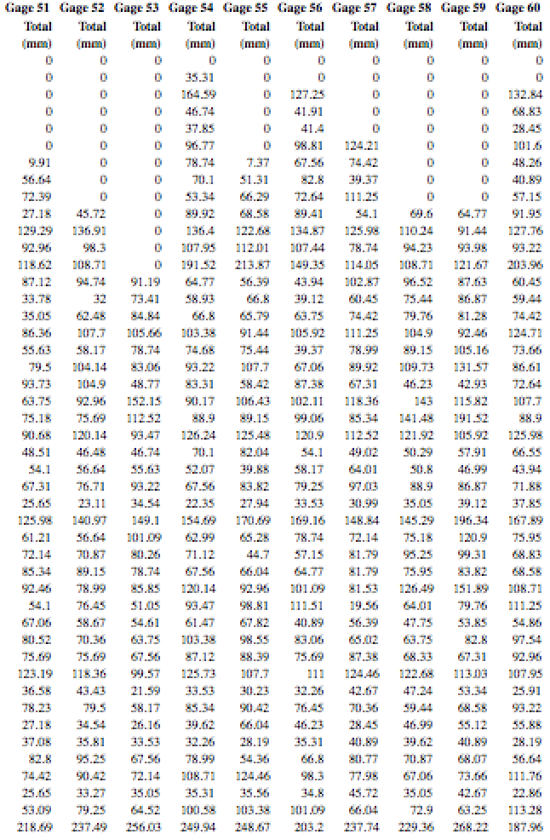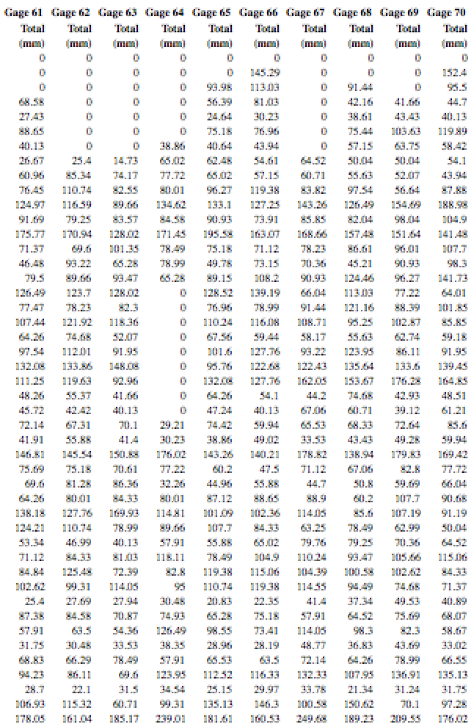
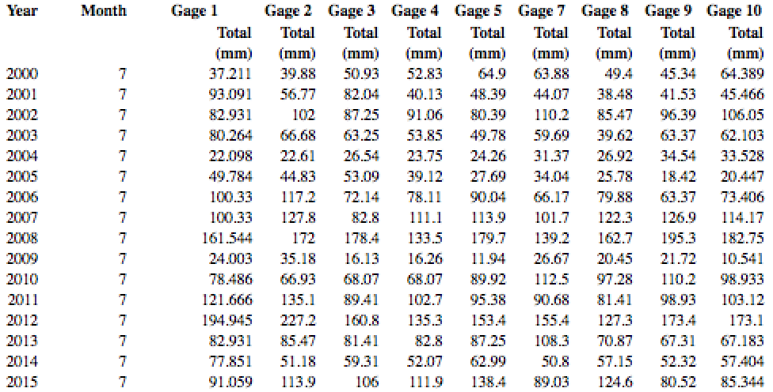
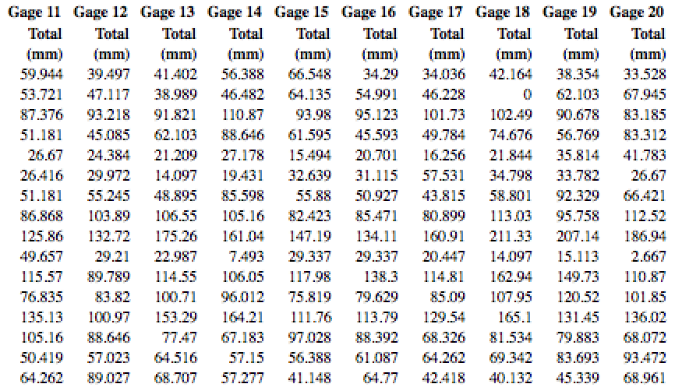
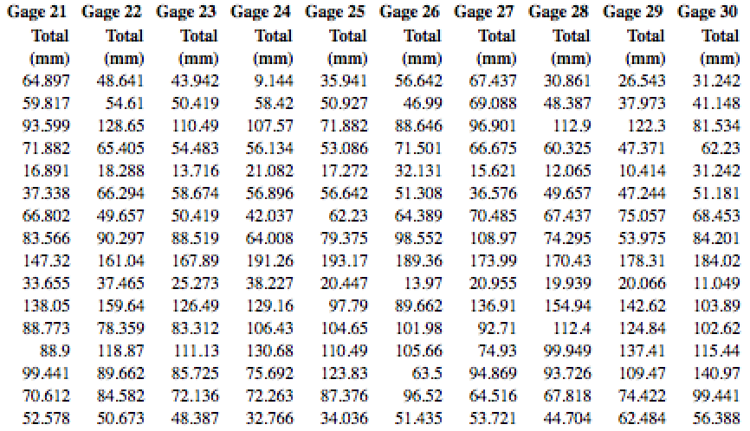
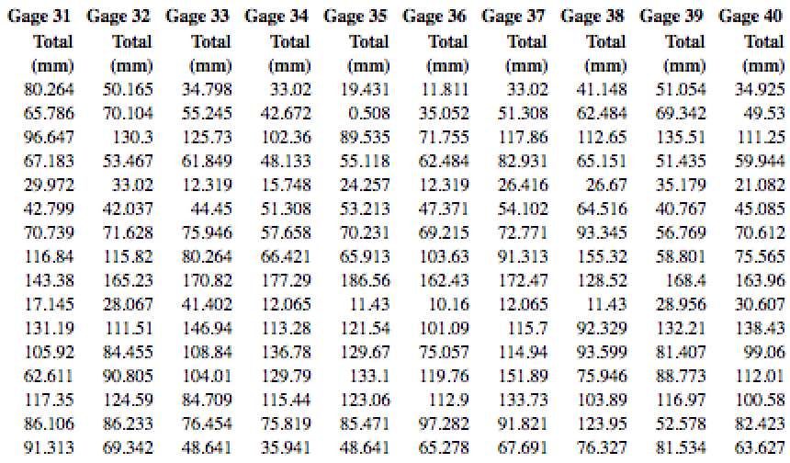
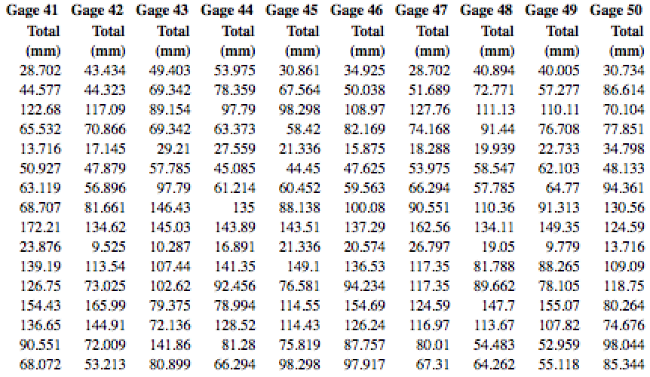
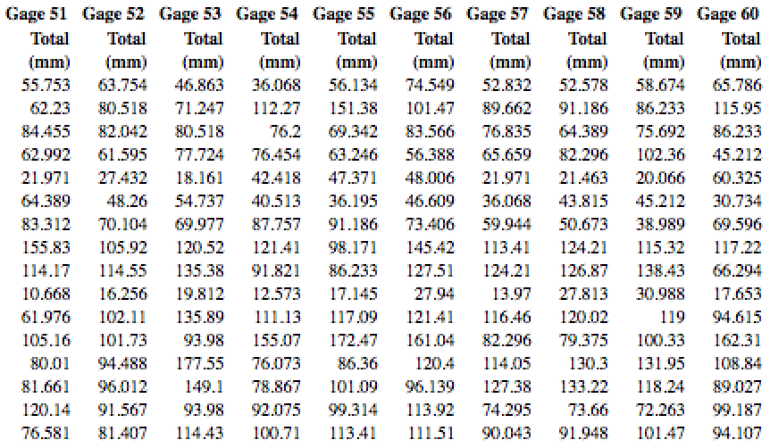
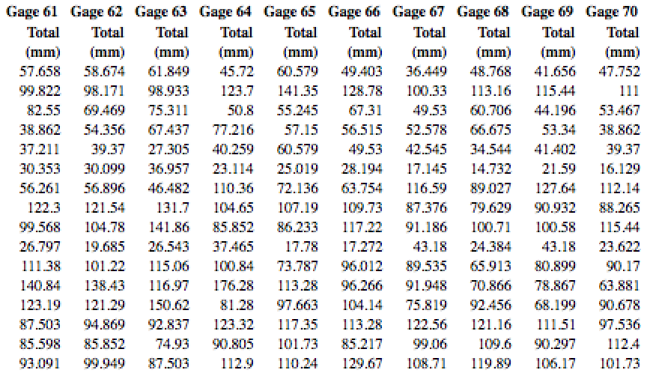
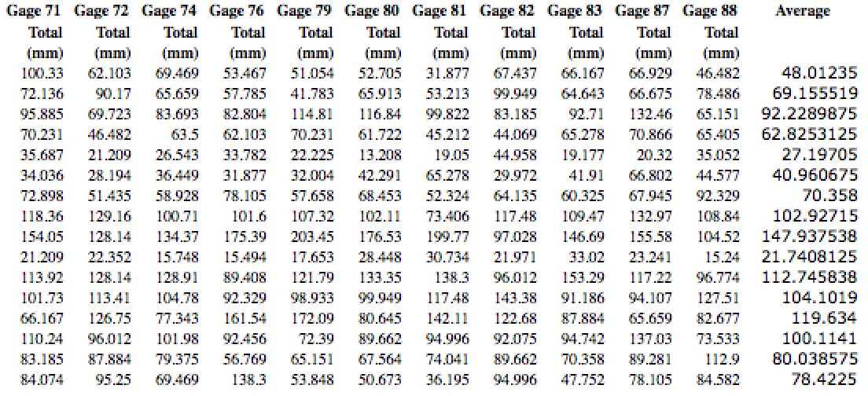

Appendix D
Annual Runoff
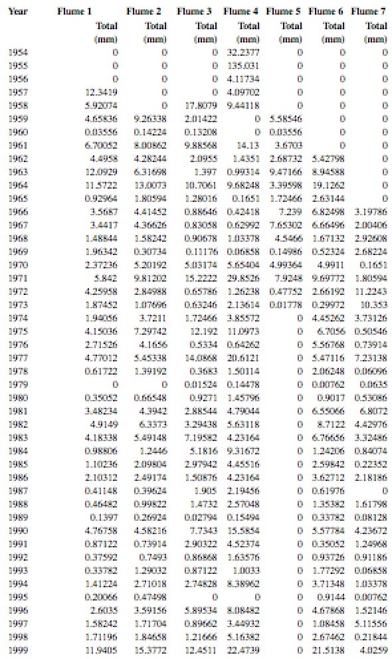
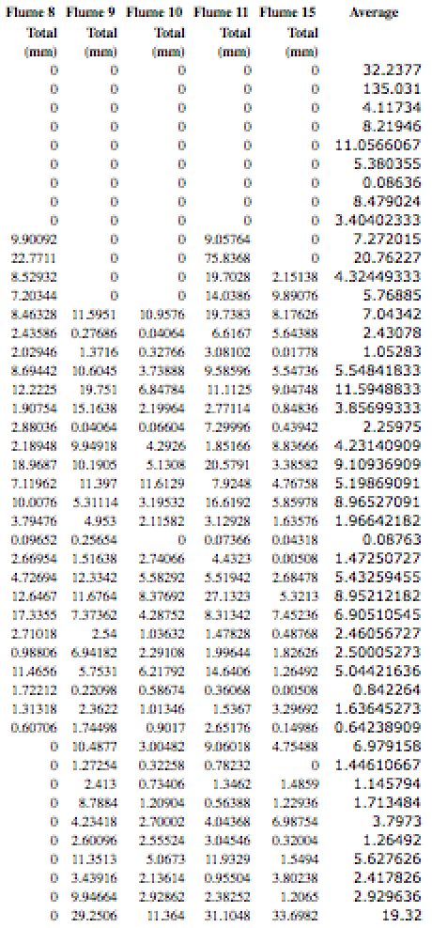
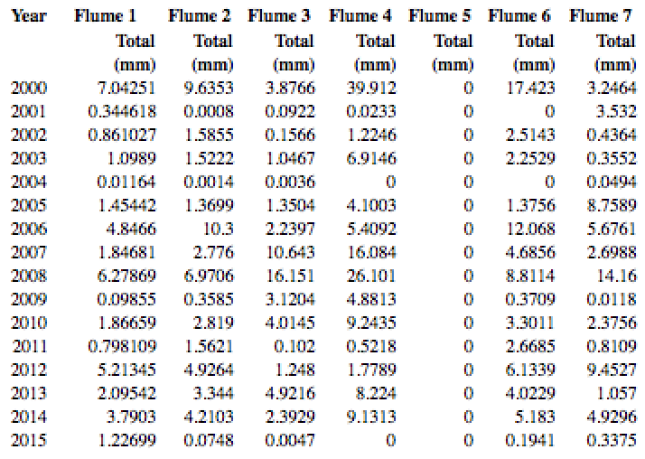
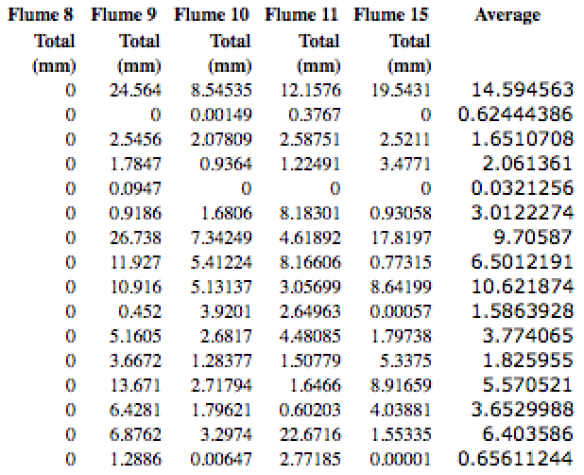

* The Walnut Gulch Experimental Watershed, being a government-operated and funded research center, would likely be a reliable source of continuous long-term data for studies such as this one. The extent to which the center discusses chance for error, such as the calibration of wrist-watches and supply of back-up watches in the case of a dead battery during scheduled gauge checks, is indicative of the close attention to reliable data for any who need it.
** For the purpose of this study, I am limited by the extent to which the WGEW accurately publishes observed data. I am also limited by the availability of such sources in the first place; I am unable to take data on my own from Arizona, and must directly rely on published material for the body of my research.

